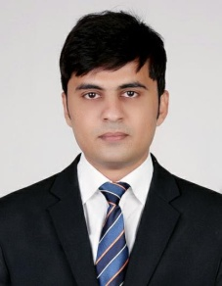
ARSHAD

Email id: arshad.375062@2freemail.com

Career Objective:

I would like a career that gives me rich exposure through diverse assignment and working with people of high caliber. I would constantly look out for challenges, which would help me to achieve my personal and professional goal.

Work Experience:

Worked with Axis bank as Business Development Executive.

Three months of Exprience in CIMS Infotech Pvt Ltd.

Summer Internship:

Sales Executive in Reliance Retail Ltd.

Project: Increase profitability in F&V

- Company: Reliance fresh, New Delhi

- Period: June 1 to July 13th, 2016

Winter Training

- A study on effect of online buying on local retailer.

Academic Qualification

- Master’s in Business Administration from SAM HIGGIN BOTTOM OF AGRICULTURE TECHNOLOGY AND SCIENCE specialization with marketing and finance.

  - Graduation in Commerce from Allahabad University with specialization in Insurance

  - Working knowledge in computer basics and Microsoft office tools.

Declaration:

I hereby solemnly affirm that all the details provided above are true to the bestof my knowledge.

Date: 12/09/2017 Arshad

Place: UAE

