MARK

Email: mark.375064@2freemail.com

Summary

Self-motivated Inventory Assistant with 10+ experience offering a strong work ethnic and determination to complete tasks in a timely manner. Possess an accurate and detail-oriented in leading inventory and warehousing operations. Delegated to oversee the assigned department of 20+ employees in one of the biggest mall in the Philippines

Education
2-Year Aircraft Maintenance Technology (AMT)
Philippine College of Aeronautics Science and Technology
INC. 2001-2003EL-98, Jaro Iloilo City, Philippines

Qualifications
- Outstanding inventory management techniques
- Computer literate and data entry (Word, Excel, PowerPoint, Lotus 1, 2, 3 & Open Office)
- Safety-oriented
- Multi-tasking
- Superb customer service
- Proficient in speaking, reading and writing in English
- Highly skilled in driving light vehicles

Work Experience

- Inventory Assistant (Key Custodian Reliever) (August 2009 - March 2017)
Metro Manila Shopping Mecca (MMSM - DELGADO)
Corner Delgado Valeria Street, Iloilo City, Philippines
- Responsible for monitoring and accurate documentation of all stocks movement in warehouse and selling area
- Review requisition orders to gauge accuracy of materials and equipment information
- Investigate inventory errors and perform corrective measures
- Identify and distribute stock to appropriate locations within and out of the company premises
- Maintaining confidentiality of work related information and materials
- Provide administrative assistance in relation to warehouse and inventory control activities
- Maintained all relevant inventory paperwork and entered accurate inventory data in computer system

Achievements:
I managed to find discrepancies during physical count and conduct inspection
Recommended to stock clerk promoted as Inventory Assistant in 2009
Recognized as Inventory Supervisor in 2015
Awarded as Perfect attendance in 2015
Appreciated for being Loyal Employee (5 years) in 2012
Honored for being a Star Employee in 2011

- Stock Clerk (May 2007 - August 2009)
Metro Manila Shopping Mecca (MMSM - DELGADO)
Corner Delgado Valeria Street, Iloilo City, Philippines
- Ensure the completeness of inventory documentation
- Maintain the accuracy of stock paper work

- Receiving and Dispatching Unit Forwarder (February - May 2007)
Metro Manila Shopping Mecca (MMSM - DELGADO)
Corner Delgado Valeria Street, Iloilo City, Philippines
- Accept delivered packages and ensure proper amount is inside and distribute to every department
- Check the Purchase Order before receiving the goods
- Transfer the goods in designated branches

Seminars and Workshops/ Trainings Attended

On the Job Training
Nomad N22B/C Aircraft & Airframe/Landing Gear Familiarization (April-July 2003)

On the Job Training
C - 130 B/H and L - 100 - 20 type of aircraft (September-December 2003)

Character Reference

Available upon request

I, hereby certify that the above information is true and correct to the best of my knowledge and belief.

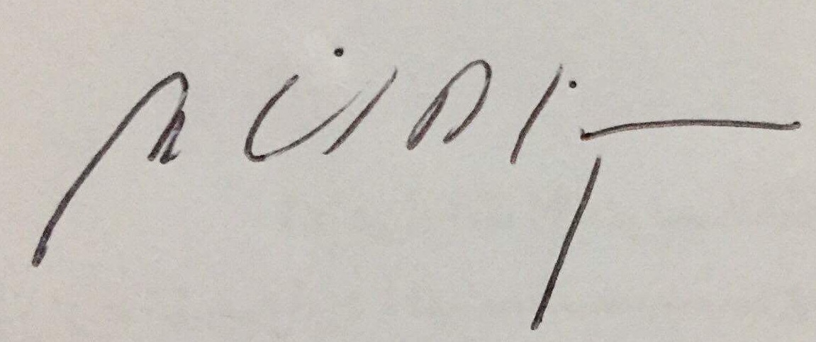

______________________
MARK

