SIDHARTH 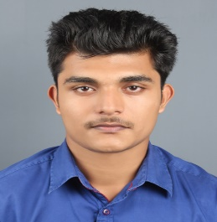
Email: sidharth.375065@2freemail.com
ASPIRING MECHANICAL ENGINEER
Keen to have a challenging and performance oriented career with an organization which recognizes my true potential and provides me avenues for professional growth in the field of Mechanical Engineering/ Production / Quality Control / Designing/ Manufacturing/Planning/Maintenance.
SUMMARY OF SKILLS

- Sincere and hard working, qualified with BE in Mechanical Engineering from Anna University; accented with the latest trends & techniques of the field & determined to carve a niche in the industry.

- Comprehensive understanding of Heat Transfer, I. C. Engines, Thermodynamics, Transmission System, Machines and Manufacturing Process, Designing, Combustion, Production, Quality Control, Operations & Maintenance and Fuel Technology.

- Equipped with the knowledge of various technical aspects of the subject-line related to Industrial Engineering, Production Technology, Handling Machines Breakdowns, Preventive Maintenance, planned Maintenance, Overhauling, Product Development and Inventory Control.

- Successfully completed projects on ‘Design of Heat Exchanger to recover the waste heat from the calciner’ as part of the academic curriculum. Technically proficient with Auto cad , Revit MEP, Primavera, Microsoft word, Windows and Internet Applications.

- Highly motivated, positive and goal-oriented, with analytical approach, good communication and presentation skills; enriched with the ability to learn new techniques & concepts in short span of time, work in teams and perform above expectations.
ACADEMIC CREDENTIALS

BE in Mechanical Engineering 2017
Maria College of Engineering and Technology, Anna University, First class(66%)

Technical Skills
Auto cad , Revit MEP, Primavera, Microsoft word, Windows and Internet Applications

Academic Projects
Title: Design of Heat Exchanger to recover the waste heat from the calciner
Synopsis: Travancore Titanium Product Ltd. is an establishment for producing Tio2 in detail. We have designed a SHELL and TUBE heat exchanger that can be used to preheat the air during
calcinations process.
PERSONAL DETAILS

Date of Birth: 7th March, 1995
Languages Known: English, Tamil and Malayalam
Visa status: On visit visa (Expires on 9th feb)
References: Available on request

