CURRICULUM VITAE

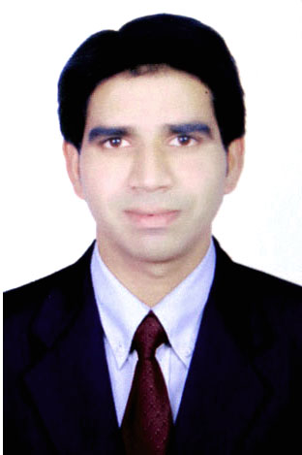

ABDUL
Accountant with 3.5 years of experience in UAE
Holding UAE driving License.
E-mail: Abdul.375075@2freemail.com
------------------------------------------------------------------------------------------------------------------------------------------------------------------------------------

Objectives:-

To obtain a challenging responsibility position in a professionally managed organization, where in, I can contribute to the successful growth of the organization utilization my skills and work and also improve my professional skills.

Educational Qualification:-

➢ Master of Business Administration from Jawaharlal Nehru Technological University.
➢ Bachelor of Commerce from Osmania University.

Computer & Technical Skills:-

- Accounting packages
- Tally ERP 7.2 & 9.0
- Peach tree
- Focus
- Wings
- PMS
- Typing speed (60 wpm)
- Ms Office (Word, Excel, Outlook and Power point)
- Internet Concept, Browsing & Mailing

Work Experience:-

- Worked in “SAFE PRINTERS LLC” as an Accountant from May-2014 to Nov-2017 (U.A.E).

- Job description: - My duties and responsibilities are comprises mainly Manage to all company documents
and records in a systematic Manner in (Tally ERP9) software.
- Prepare Vouchers, Invoices Like Sales, Purchase, Receipt, Payment Etc.
- Prepare Bank Reconciliation Statement.
- Maintain Day to Day Activities.
- Prepare Monthly Trail Balance and Profit & Loss accounts.
- Handling Petty Cash Book.
- Prepare LPO (Local Purchase order) for material purchase.
- Prepare Debtors Statement & follow-up for payments.
- Bank Account Activities Cheques deposits, cash deposits and cash withdrawals.
- Coordinate with Sales Department for their work and client meetings, Quotations sent and other work related activities.
- Prepare Received, Payment and Petty cash vouchers.
- Online Payments and online Receipts activities.
- Prepaid Sales invoices to the clients.
- Maintain Debtor’s Statement & Creditor’s Statement.
- Bank activities like collected document from bank and follow-up with the bank for all the bank transactions.
- Handling Cash control and Payroll Accounts.
- Monitoring organization working activities.
- Prepare Cheques for the Suppliers for their payments and entry into the software.
- Compiling monthly Management reports Sales reports, Customers and Suppliers age analysis
- Prepare MIS reports weekly and monthly wise Company financial performance.
- Maintain customer records for future activities.
- Keep Passport copies secure in locker employees of the organization.
- Company important documents keep safe and secured in security lockers.
- Prepare salaries WPS for all the employees of the Organization and forward it to the bank for salary credits.
- Preparing leave salaries according to working days months years.
- Prepare overtime salaries, upon overtime work activities.
- Using outlook mailing system for clients’ responses sent outstanding statements to the clients.
- Reconciliation of debtors and creditors accounts statements to eliminate discrepancies.
- Payment and journal Vouchers adjustments debit to credits.
- Prepare PDF files for client’s statements.
- Quotations sent for client approval using outlook system.
- Update day to day reports to all the management etc.

- Worked in “JANKIDAS ENGINEERING CO PVT LTD” as an Assistant Accountant for 1 year (India).

- Job description: - My duties and responsibilities comprise mainly of the following tasks on Computer (Tally ERP-7) Accounting packages.
- Prepare Vouchers, Invoices Like Sales, Purchase, Receipt, Payment Etc.
- Prepare Bank Reconciliation Statement.
- Maintain Debtor’s Statement & Creditor’s Statement.
- Maintain Day to Day Activities.
- Handling Petty Cash Book.
- Prepare Journal Entries In The Books Of Accounts.
- Bank Accounts Activities like Deposit Cheques into the Bank.
- Prepare Monthly Trail Balance, Profit & Loss accounts, and for the yearend Balance Sheet under senior Accountant.
- Prepare Vat duty and Excise duty on sales and purchase.
- Online payments and online banking activity.
- Verifying and documenting of documents relating to payable accounts
- Maintain Customers Records forwarding their queries and problem to the senior accountant.
- Update day to day reports to all the management etc.
- Payment and journal Vouchers.

Inter Personal Skills & Strength:-

Effective Communication Skills, Ability to Work hard Learns Quickly from others and towards in a team towards success.

Hardworking and result oriented as an individual and in a team.

Always loyal to my authorities.

Personal information:-

Name : ABDUL

Date of birth : 07-12-1987

Marital Status : Single

Nationality : Indian Muslim

Language known : English, Urdu, Hindi & Telugu.

Place : Dubai. U.A.E

Driving License : Holding UAE Driving License

Date : 2017 yours sincerely.
Place : U.A.E (Abdul)

