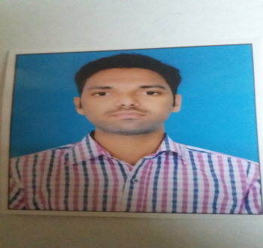
CURRICULUM VITAE
AHMED
Email Id : - ahmed.375076@2freemail.com
CAREER OBJECTIVE:-
To be a Mechanical Engineer with a leading corporate of hi-tech surroundings accompanied with committed & dedicated people, who will help me discover myself entirely and realize my potential. I am enthusiastic to work as a key player in a challenging & inventive environment.

EDUCATION QUALIFICATION:-
- B-Tech Mechanical Engineering.
Form Jawaharlal Nehru Technology University at Hyderabad in the year 2013 – 2016
- Diploma in Mechanical Engineering.
From State Board of Technical Education and Training
- State Secondary Class
From State Board of Secondary Education.
PROJECT IN DIPLOMA:-
Project Successfully Completed is fuel Injector system
PROJECCT IN B-TECH:-
Project successfully completed in wet riser Installation
SOFTWARE PROFICEINCY:-
Operating system : Windows 98. 2000, windows XP & windows7….etc.
Office Automation : MS office MS ACCESS
Software Knowledge of HVAC and MEP
Knowledge of Duct design
Knowledge on piping design for the chilled water services
Knowledge on Heat load calculation
To control fir and safety
Design of System : Auto Cad and Knowledge of cam.
EXPERIENCES :-
3 YEARS WORKING IN RELVENT FIELD IN MECHANICAL WORKS AND OFFICE WORKS.
MY RESPONSIBILITIES:-
- Handle and Control the fire and safety on the projects.
- It is handle the operating the machines ad man powers.
- Mechanical Electrical Plumbing the design inspections
- Provide engineering input and support to the Draughtsman in the preparation of the work shop design.
- Heat Ventilation Air Conditioning the projects on control the power o machines
- It is submitted and obtain approvals from relevant authorities.
- Check review and approve shop drawing
- To Inspection the projects relevant authorities.
- Office management in the controlling the material.
- Computer typing and presentation.
- Review comments received from the consultant.
- Visit and discuss compliance issues and matters with relevant authorities.
- To ensure that the work is completed in time with the given specification.
PERSONAL DETAILS:-

Name : Ahmed
Date of birth : 12-07-1992
Nationality : Indian
Date of issue : 08-08-2012
Date of Expiry : 07-08-2022
e-mail id : ahmed.375076@2freemail.com
Languages Known : English, Hindi, Telugu and Urdu.
Hobbies : Playing Cricket, Football, Carom,Chess..etc.

Being technically sound, young and enthusiastic I am confident that I can fulfill your esteemed organization’ requirements. I wish ad hope that I’II get the privilege of serving your organization.

Date :- 02-12-2017
Place :- DUBAI. (AHMED)

