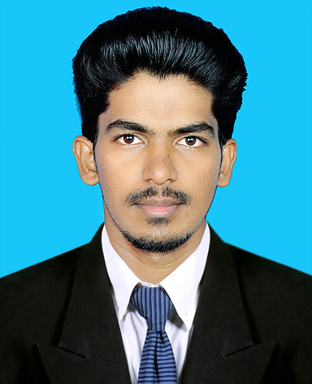

**CURRICULUM VITAE**

**SHUKOOR**

[Shukoor.375081@2freemail.com](mailto:Shukoor.375081@2freemail.com)

**B.Tech Electronics & Communication Engineering**

(U.A.E Embassy attested graduation certificate)

**Professional Summary**

|  |
| --- |
| A proven **Network Engineer** with Total 2.5  **years** |
| years hands-on experiences in **Network Administration**/**Monitoring/System Administration/Technical Support/Telecom.** |
| To work with an organisation that provides the opportunities for my growth as a professional in my career field and also to be a part of a highly dynamic and challenging team that support team work and promote leadership qualities within an organization. |
|  |
|  |
|  |
| **Professional Experience (2.5 years)** |
| * **Network Engineer at Quadgen Wireless Solutions pvt Ltd,** Bangalore, India   (Feb 2016 – September 2017)   * **System Engineer at** **Modwin Networks Private Limited,** Kerala, India   (Feb 2015 – October 2015) | |
| **Technical Qualifications** | |

BTech (Electronics & Communication)

IT/ Networking :

|  |
| --- |
| **Present address/Visa** |
| **Location : Sharjah** |
| **Visa status : Visit** |
| **Visa expiry : 03/03/2018** |
|  |
| **Personal Data** |
| Date of Birth : 20/09/1991 Gender : Male |
| Marital Status : Unmarried |
| Languages Known : English, Malayalam |
| Hindi  Nationality : Indian |
|  |
| **Passport Details** |
|  |
| Date of issue : 09/09/2015 |
| Date of expiry : 08/09/2025 |
|  |
|  |

* MCSA
* CCNA
* N+

**JOBS AND RESPONSIBILITIES**

* Configuration of Access points in Wlan controllers
* Montoring and Managing of Different Wireless LAN controllers such as SCG,VSCG,Aruba and Mojo
* Taking the Backups of differenet wireless lan controllers
* Monitoring and Tracking the status of Access points in Wlan controllers
* Configuration and Troubleshooting of all Types wireless Access points
* Configuration of D-Link switch and point to point propellers
* Vlan Configuration,trunking and network checking through vlan tag adaptor
* Autofailover switch configuration
* Installation of Windows Server and windows operating system
* Installation and configuration of Domain Controller,Adds,Dhcp.Dns
* Installation and configuration of Proxy server and Microsoft outlook
* Configuration and taking the backups of CCTV

**TECHNICAL SKILLS**

* Knowledge about Wireless Networking
* Knowledge in basic networking.
* Knowledge in Routing and switching
* Switches: Basic configuration and VLAN setup on Cisco switches.
* Good understanding in OSI model,Tcp/ip protocol suite
* Knowledge in windows server 2012.
* Knowledge in server 2012 user policy and permissions.
* Installation of windows server, Active directory, DNS and DHCP.
* Installation, management, up gradation and troubleshooting (hardware & software) of different office use IT equipment’s.
* Microsoft outlook configuration
* Installation and trouble shooting of all windows operating system.
* Knowledge in pc hardware and software trouble shooting.

**EDUCATIONAL QUALIFICATION**

**EDUCATIONAL QUALIFICATION**

|  |  |  |  |  |
| --- | --- | --- | --- | --- |
| **Course** | **Institution** | **University/Board** | **Year of passing** | **Percentage** |
| B.Tech: Electronics and Communication Engineering | Calicut University Institute of Engineering & Technology | Calicut University | 2014 | 67 |
| PLUS TWO | PMSAPT higher secondary school | State Board of Examination, Kerala | 2009 | 83 |
| SSLC | FAROOK higher secondary school | State Board of Examination, Kerala | 2007 | 85 |

**Declaration**

I hereby declare that the above information is true and correct to the best of my knowledge and behalf.

Yours Sincerely

Place : **SHUKOOR**