CURRICULUM VITAE
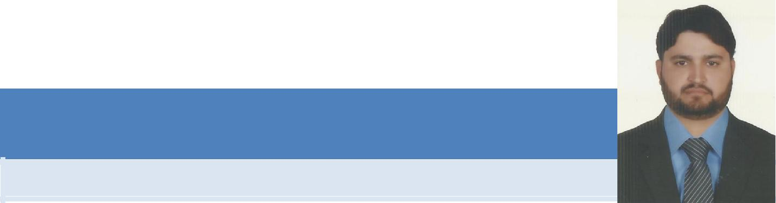

ABDUL

OBJECTIVE

To find a challenging position in an Establishment or Organization where I can utilize my knowledge & skills, to bring about a positive difference and contribute to the growth of the organization as far as possible.

PERSONALS DATA

Date of Birth | : | 20th April, 1984
Marital Status | : | Married
Nationality | : | Pakistani
N.I.C. No. | : | 161012-555676-1
Religion | : | Islam
Domicile | : | Mardan, Khyber Pakhtunkhwa.
E-mail | : | Abdul.375091@2freemail.com

EDUCATION

Electrical Certificate Board of Technical Education Peshawar.
F.A Board of Intermediate & Secondary Education Mardan.

S.S.C Board of Intermediate & Secondary Education Peshawar.

EXPERIENCE

- Currently working as electrical & Fire alarm Forman in Pluto Electro Mech Cont Co Dubai UAE from last 9 years.
 | Projects: | Dubai Investment Park G+2 in Dubai
 | Company Name: | Pluto Electro-Mech-Cont Co. Dubai UAE
 | Session | 2006 to 2007
 | Projects: | International City G+3 in Dubai
 | Company Name: | Pluto Electro-Mech-Cont Co. Dubai UAE
 | Session | 2008 to 2009
 | Projects: | Al Majaz Tower Buhira Cornis 40+G+M+40+H Floors in
 |  | Sharjah
 | Company Name: | Pluto Electro-Mech-Cont Co. Dubai UAE
 | Session | 2010 to 2011
 | Projects: | Ajman Academy in Ajman
 | Company Name: | Pluto Electro-Mech-Cont Co. Dubai UAE
 | Session | 2011 to 2012

CURRICULUM VITAE

 | Projects: | Imperial Tower Jumaira Village
 | Company Name: | Pluto Electro-Mech-Cont Co. Dubai UAE
 | Session | 2012 to 2014
 | Projects: | Govt: Contracting Work in Pakistan.
 | Company Name: | Akhter Ali Govt: Contracting Co. Pakistan.
 | Session | 2002 to 2005

PERSONAL SKILLS

- Motivation / Mobilization / Leadership.

- Fluency in English, Urdu, Pashto, Arabic.

- Team Work, Independent Work.

- Tolerance, Patience, Good Manners & Forward-look nature.

STRENGTHS

I know all electrical work like SMBD, DB, dressing and wiring, LV Pannel Dressing, cable termination and Glanding, all piping and knows all FIRE ALARM working. So I hope to you will utilize my capabilities for your esteemed company.

