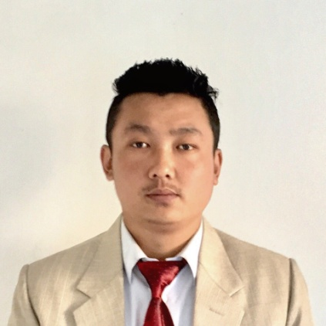
Prasant
Email: prasant.375093@2freemail.com
VISA STATUS: Visit Visa
Nationality: Indian

SUMMARY

Customer service and sales expert who identifies customer needs and delivers effective solutions to problems. Committed to providing high-quality customer care to create a positive customer service experience. Personable and professional under pressure with motivated, energetic nature.

SKILLS

- Savvy negotiator  - Quick learner | - Extensive phone and in-person customer service experience | - Effective team player
- Superior organization skills | - Dependable and Reliable | - Cheerful and Energetic
- Reliable worker | - Collaborative | - MS Office proficient

PROFESSIONAL EXPERIENCE
Troonet India
Customer Service Executive, Duration: October 2016 till oct 2017
- Cold call target accounts to establish new customers
- Offer information on product lines, service offerings, and demonstrations
- Provide the highest standards of customer service by demonstrating excellent knowledge of products and customer satisfaction
- Control and set monthly packages and plans according to the market
- To build relations that continuously adds value and growth to the company
- Troubleshoot problems and provide solutions to customers on prompt basis
- Help in the administrative work (sending replacement mails, daily sales data, banking, etc.)
Wish net India
Sales Executive, Duration: 2013 till 2015
- Handle inbound and out bound calls.
- Provide the highest standards of customer service by demonstrating excellent knowledge of products and customer satisfaction
- Customer assistance over the phone and in person as well.
- Maximize sales & ensure customer focus is prioritized at all time.
- Manage stock replenishment
- Ensure communication is effective throughout store
- Weekly / daily analysis of commercial reports & implementation of action plans where necessary
EDUCATION

Institution | Qualification | Year of Passing | University
Mirik College | Graduation(ENGLISH HONOURS) | 2012 | N.B.U
N.B.U | M.A(ENGLISH) | 2015 | N.B.U
Yogi Vemana University | B.Ed | 2016 | Yogi Vemana University

PERSONAL DETAILS
Gender: Male
Nationality : Indian
Birth Date : 07/11/1990
Marital Status: Unmarried
Languages Known : English, Hindi and Nepali

