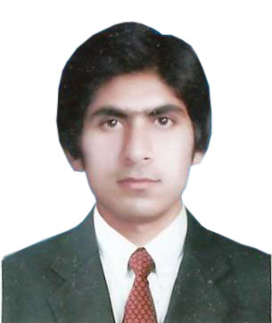
Hafiz

Email: hafiz.375103@freemail.com
Visa status: Visit Visa expiry 4 February

CAREER OBJECTIVE:
I am looking for a position that will build my skills and provide me ample scope for growth and contribute to the organization’s goals, by effectively using the conceptual skill and knowledge through education.

SKILLS AND COMPITENCIES:
- Confidently able to work independently or in a team to deal effectively with educators & employees.
- Flair to organize & prioritize tasks to meet deadlines.
- Have a good level command over English and Urdu Languages.
- Ability to deal and negotiate costumers
- Thorough understanding of Accounting Software Computer software, such as Microsoft office, Visual Basic and turbo C
- Laptop, PC troubleshooting Hardware Software.
- Microsoft windows XP, 7, 8, 10.
- Knowledge of Templates
- Knowledge of online work on souq.com and noon.com

BACHELORS IN COMPUTER:
Details of Subjects:
- Principal Accounting
- Cost Accounting
- Operating system
- C In Hand
- Statistics
- IT Series
- System Analyst & Design
- Visual Basic
- Data Base
- Data Structure

EXPERIENCE:
- 6 months Experience as an accountant in AL KHETOUT AL AMAMYAH CONT. CO. LLC Sharjah
- 1 Year work Experience as a Computer Operator in EFU Life Insurance Bahawalpur. (Pakistan)

Duties and Responsibilities:
- Making Invoices,
- Record Daily Expenses,
- Record General Entries, Prepare Cash book.
- Collecting and accounting for payments from customers
- Reporting reconciliation of petty cash on daily basis
- Coordinating with the bank on all related matters of the company
- Recording and maintaining all supporting documents

PERSONAL DETAILS:
Nationality: Pakistani
Date of birth: 02-08-1994
Religion: Islam
Gender: Male
Marital status: Single
Languages known: English, Urdu, Punjabi

HOBBIES:
Like to indulge in sports like Football, cricket.
Enjoy and actively participate in a wide variety of sports and creative activities.

DECLARATION:
I hereby declared that the above furnished information is true and correct to the best of my knowledge and belief. If selected I assure that I would perform to the best of my abilities early awaiting a positive response.

