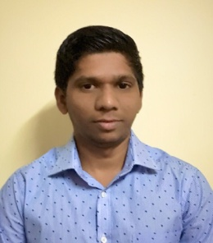
Shamlan
Dubai
United Arab Emirates
Email: shamlan.375105@2freemail.com

Career Objective

To obtain an Accounting Assistant position with ManTech where knowledge and experience of managing accounting systems is put to prudent use in order to manage smooth work flow of the company’s accounts base.

Field of Expertise and Strengths

- Communication Skills
- Computer Skills
- Interpersonal Skills
- Ability to work under pressure

Career History

Burger King (BK): Riyadh – Saudi Arabia (Sep 2015 to Sep 2017)
Fast Food Restaurant
Job Role – Cashier

Burger King is an American global chain of hamburger fast food restaurant. Headquartered established in Miami, Florida. It was founded in 1954.

Key Responsibilities
- Greeting the customer
- Suggesting new food items and promotions
- Taking food and desert order
- Providing excellent customer care
- Always handle care with money
- Maintaining a cleanly work environment
- Assist in food preparation and additional job duties

Big City Lovers (PVT) LTD: Kaluthara – Sri Lanka (Apr 2013 to July 2015)

Retail and Sales
Designation: Account Assistant
Key Responsibilitie
- Collecting all the bills from the shop daily
- Making the invoices and system entry in company main software
- Preparing statutory accounts
- Calculating and checking to make sure payments, amounts and records are correct.
- Handling and writing cheques
- Managing petty cash transactions
- End of the month preparing salary for the staffs

Academic Strengths

- Successfully completed Diploma in Information Communication Technology Applications(DICTA)
- Successfully completed in AAT LEVEL – 2 Certificate in Accounting
- Successfully completed in Computerized Accounting
- Successfully completed in Architecture 3D Visualizing
- Successfully completed in G.C.E (A/L) Examination in 2012
- Successfully completed in G.C.E (O/L) Examination in 2009

Computer Literacy

- Adobe Photoshop and Graphic Application
- MS Word, Excel, and all other MS Office Suite Applications.
- Good Exposure in Computer Accounting Software Programs.

Language Skills

- English Fluent speaking, writing and understanding
- Arabic Fluent speaking and understanding
- Tamil Fluent speaking, writing and understanding
- Sinhala Fluent speaking, writing and understanding

Personal Information

Full Name : Shamlan
Nationality : Sri Lankan
Date of Birth : 12th September 1993
Civil Status : Single
Visa Status : Visit Visa
Languages : Arabic, English, Tamil, Sinhala and Malayalam

SHAMLAN 06th December 2017

