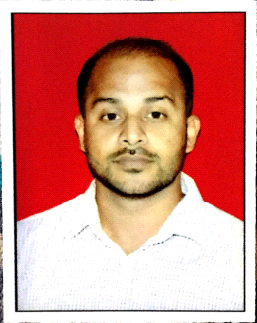
FAHAD

Email : fahad.375121@2freemail.com

- A Result oriented IT Professional with over 2+ years of experience in IT industry, specializing in turnarounds, revitalization's and rapid growth organizations.
- A good team player, excellent written and oral communication skills able to handle pressure and do multi-tasking.

Educational Qualification

Program | Year
MCA (Master in Computer Application) | Pursuing
BCA (Bachelor in Computer Application) | 2014
H.S.C | 2010
S.S.C | 2008

Work Summary

Bitwin Computers, India April 2016 –May 2017

Title: IT Support Engineer.

Job Profile:
- Installation and maintenance of various user applications locally.
- Installing, configuring and troubleshooting Outlook, MS Office, Citrix, Windows Live Mail, SSL VPN and various basic applications remotely.
- Software/hardware/network troubleshooting.
- Installation and configuration of network and standalone printers.
- Networking and structured cabling with vendor coordination.
- User account administration, i.e., account creation and management and password resets on Active Directory.
- Updating Antivirus and running AV patches on standalone machines.

- System Installation & assembling, OS installation/ troubleshooting, Workgroup.

Dalvi Bros, India January 2015 — Feb 2016

Title: Desktop Engineer

Job Profile:
- Mean time to repair - Onsite analysis, diagnosis and resolution of desktop problems for end users.
- Collaborate with 3rd level support to prevent system downtime.
- Assist in user/hardware movement and branch relocation's.
- Software/hardware/network troubleshooting.
- Customer satisfaction, Perform quality work on all service requests/incidents.
- User account administration, i.e., account creation and management and password resets on Active Directory.
- Windows Administration.
- System Installation & assembling, OS installation/ troubleshooting, Workgroup.

Professional Qualification
CCNA (Course) | May 2016 — June 2016
Excel Institute of Network Technologies
- Sound Knowledge of Cisco Network Technologies.
- IPv4, Subnet, Host calculation, Routing and switching.

Computer Skills

- Operating Systems: Windows XP, Vista, 7, 8/8.1.
- Languages (Skill- Basic): HTML, PHP.
- Reporting: MS- Office (2003/2007/2010/2013)
- Backup & Recovery:Stellar Phoenix Data recovery, Win Hex.
- MySql, SQL Server 2014, Postgres.
- Good Knowledge of Internet & Network technologies.
- Adobe Photoshop, Corel Draw, Dreamweaver.

Personal Details

- Date of Birth: 22 January 1992

- Marital Status: Single.

- Nationality: Indian.

- Languages Known: English, Hindi, & Marathi.

