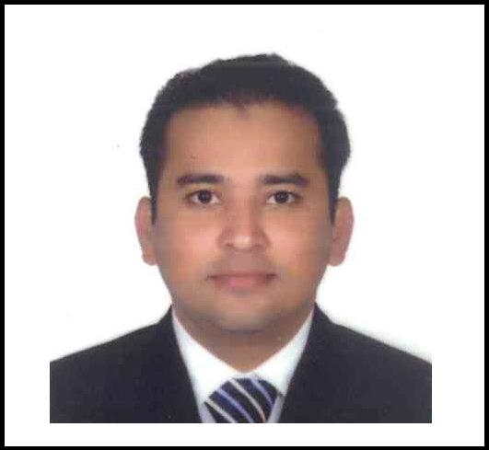
RIYAS

Email: riyas.375138@2freemail.com

Enterprising leader & planner with a strong record of contributions in streamlining project operations, seeking senior level assignments in Detailed Engineering & Project Management with an organisation of high repute, preferably in commercial & Oil & Gas sector

Profile Summary:

 | Design Engineering |  | A Competent Professional with over 10 years of experience in delivering
 |  |  |  | successful projects with innovative solutions & ensuring internal coordination with
 | Detailed Engineering |  |  | Engineering Teams
 |  |  |  | Identifying the qualification of design by contributing to specification of various
 | Project Management |  |  | tests; conducting detailed engineering with safety aspects and preparing master
 |  |  |  | schedules for all of them
 | Quality Compliance |  | Literate with BS, AISC, IS, Middle East Standards
 |  |  | Deft in creating designs & plans, layouts, working drawings and managing
 | Strategic Planning |  |  | resources to ensure execution of projects within time and budgeted parameters
 |  |  | Effectiveness in reviewing tasks, conducting studies & performing research to
 | Team Management |  |  | assess feasibility of designs while carrying out complex calculations
 |  |  | Ardent in using design tools with proficiency in implementing development
 | Training & Development |  |  | initiatives and developing parts in compliance with pre-set technical specifications
 | Liaison & Coordination |  | An effective leader with honed communication, people management, analytical
 |  |  |  | and coordination skills

Organisational Experience:

JAN’2015- TILL NOW: Unger steel middle east fze, Sharjah as Senior Structural Detailer

July’2013- December2014’: Alumco LLC.Dubai investment part Dubai. UAE. as Steel designer( Tekla structure) July’2011-Jul’2013- Cleveland Bridge Steel Company Ltd., Al-Jubail, Saudi Arabia as Senior Structural Detailing Engineer

December’2010-Jul’2011- Saipem india projects ltd (Deputat from Blackston group technology) Nov’2008-July’2010: William Hare India Pvt. Ltd., Chennai as Steel Detailing Engineer
Nov’2006-Feb’2008Arjun project services Pvt Ltd, Jamnager Gujarat
Joined as Diploma Engineer Trainee & rose to the post of Steel Detailer
Key Result Areas:

Involved in project planning, effort estimation & work allocation & goal-setting in coordination with Engineers & Designers Ensured regular project progress reviews for delivering project within specified timelines and budget

Monitored activity at sites, reviewed project schedule, site selection, layout, detailed engineering & equipment specification and ensured cost control within budget & planning cash flow requirements

Fostered project engineering activities including preparation of project proposals, man-hour estimates, finalization of project deliverables, tendering, pre-bid engineering and preparation of BOQs (Bill of Quantity)

Developed:

o Shop drawings, Fitting Sheet Drawings and GA Drawings o Client Requirement Reports & Templates

o ABM Modeling
o NC & Plate Nesting Files
o 3D-Modeling and Connections
o Customized macros connections and standard connections o Auto Connection
Evaluated assemblies, clashes & reports in the model Raised RFIs for obtaining project information

Handled miscellaneous structure modeling

Identified training needs and imparted training to project associates & team members

Provided technical inputs & engineering support to team from conception to completion of project

Created & sustained a dynamic environment that fosters development opportunities and motivates high performance amongst team members

Education:

Diploma in Mechanical Engineering with first class from Sree Krishna Polytechnic College, Kanyakumari District, Tamil Nadu

IT Skills:
Well versed with X-Steel (Tekla Version 19 & 20,21), AutoCAD, MS-Office (Word, Excel & PowerPoint)

Personal Details:

Date of Birth: 20th Jan’1987
Languages Known: English, Tamil& Malayalam
Permanent Address: Old Mosque Street, Thiruvithamcode, Kanyakumari District, Tamil Nadu-629161
Marital Status: Married
Nationality: Indian
Passport No.: F9743885

Refer annexure for projects handled:

At Unger steel Middle East fze, Sharjah as Senior Structural Detailer
Dammam University-AAM-Steel (KSA)

Umm Wu’al Epc project (Conveying system)-Intecsa industrial (KSA) Bauxite and hydraite building- Emirates Global Aluminium - (UAE) Martyr Memorial – Government of Umm al quwain (UAE).

Ministry of interior head Quarter Building (Jeddah)-KSA. Bee’ah head Quarters - UAE (Sharjah)

At Alumco LLC.Dubai investment part. Dubai. UAE. as Steel designer( Tekla structure)

King Abdulla Financial District. (K.A.F.D) RIYADTH. Head Quarters for ministry of education. KUWAIT.

At Cleveland Bridge Steel Company Ltd., Al-Jubail, Saudi Arabia as Structural Designer (Tekla structure)

H-1119 Score Furnace-Jubail United Petrochemical Company Jubail Export Refinery Projects-Dayim Punj Lloyd, Saudi Arabia

Vessel Support Structure (Shaybah Plant)-Samsung Engineering Saudi Arabia Co. Ltd. Conveyor Belt-Gulf Consolidated Contractors.

King Abdullah Financial District (KAFD)-Saudi Binladin Group

At Saipem india projects ltd (Deputat from Blackston group technology)

SHAH GAS DEVELOPMENT E.P.C-2 & E.P.C-3 (Abu Dhabi Gas development company ltd) Air products & Chemicals, Inc (Saipem india projecta ltd)

GNL-3Z pipe rack (Technip india ltd)

At William Hare India Pvt. Ltd., Chennai as Steel Detailing Engineer
Technip Italy ltd.

OML 58 Upgrade Project-Saipem Contracting Nigeria Ltd.

At Arjun project services Pvt Ltd, Jamnager Gujarat.
Jamnager Export Refinary Project (JERP)-Reliance Engineering Associates Pvt. Ltd.

IISCO Steel Plant-West Bengal (Conveyor Gallery, Conveyor Trestle, Coke Screening Station, Junction House, Coal Crushing Station, Traveling Tripper Platform - L&T, India)

DECLARATION:
I hereby declare that the above mentioned particulars are true to the best of my knowledge.

Riyaz

