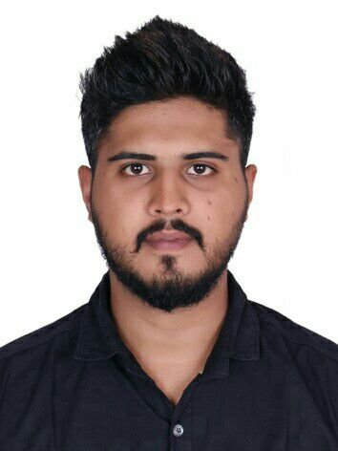
Nilesh
Email: nilesh.375149@2freemail.com

OBJECTIVE
To obtain a challenging position in a high quality environment where my resourceful experience and academic skills will add value to organizational operations.

PROFESSIONAL STRENGTHS
- Over four years of experience in the mentioned field
- Highly proficient in handling customer care services and sales
- Possess excellent communication and interpersonal skills
- Ability to deal professionally with a number of external and internal customers
- Quick learner, creative problem solving skills
- Ability to adapt to new processes within limited time frame
- Familiar with basic operating systems like Microsoft Outlook, Office and the Internet
- Self-motivator and ability to work in a fast paced work environment
- Ability to convince and satisfy customers
- Excellent team player with good listening skills

PROFESSIONAL EXPERIENCES

FIRST SOURCE SOLUTIONS LIMITED.
FEB 2012-SEPT2016
Customer Service Executive
- Sky TV talk and broadband process.
- Handling prospect customers and ensuring the sale is closed on the first call.
- Helping the existing customers upgrade their package for existing customers.
- Offering the best deal and value for the products to retain the customers looking to switch from SKY.
- Cross selling, updating the changes on the Customer service portal as per the process norms.
- Prepares daily reports on the daily activities of Customer Care team.
- Ensures that all the request, queries and complaint of customer are responded in a timely and professional manner
- Responsible for providing administrative support to customer service team
- Responsible for maintaining and developing relationships with the clients
- Shared best practices and knowledge with colleagues and teams helping achieve the sales targets

COMPUTER PROFICIENCY

- MS Word MS Office, Internet, PowerPoint.
- Knowledge of Computerised Reservation System (AMADEUS)
EDUCATION/CERTIFICATIONS

- Graduated with IATA course, IITC mumbai, 2017
- Diploma in International Airline and Time Management, 2017

- H.S.C., Mumbai University, 2011
- S.S.C., Maharashtra Board, 2008

Hobbies
Writing blogs, Volunteering for trekks and camps, Net Surfing.

PERSONAL INFORMATION

Languages known: English, Hindi, Marathi and Gujrati
References: Available on request
Nationality: Indian
Date of Birth: 10.07.1992
Gender: Male
Visa Status : Visit
------------------------------------------------------------------------------------------------------------------------------------------------------------
DECLARATION
I hereby declare that all the details furnished above are true to the best to my belief.

Nilesh

