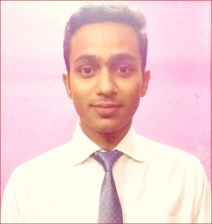
Sheezan

E–Mail: sheezan.375174@2freemail.com

An enthusiastic & high energy driven professional aspiring challenging assignments in
Civil Engineering with a reputed organization.

PROFILE SUMMARY

- A budding professional with zeal to make a winning career in Civil Engineering
- Knowledge of AutoCAD, STAAD Pro, problem-solving in MS Excel, Hand Drawings & Plans for Houses
- Insightful knowledge of the academic concepts and their applicability in the practical world
- Fruitful combination of academic expertise and leadership qualities inherent in the working style resulted into the recognition of the team at various occasions
- Possess knowledge to produce best result in pressure situation
- An effective communicator with skills to relate to people at any level of work
- Pleasing youthful personality with a zest for life, knowledge and sound understanding of technology
Possess Functional Knowledge Of:

~Site & Construction Management ~Project Management ~Contract Management

KNOWLEDGE PURVIEW

- Supervising all construction activities including providing technical inputs for methodologies of construction & coordination with site management activities
- Planning, initiating, executing and monitoring projects along time, cost and quality including technical (engineering) and techno-commercial coordination with all stakeholders
- Managing the project start-up contracts / agreements, due diligence, formulation and negotiations in co-ordination with internal and external legal / commercial teams

ACADEMIC DETAILS

- B.E. (Civil Engineering) from BIT, Bengaluru in 2017 with 61.2%
- 12th from St. Sebastian, Tengra in 2012 with 58%
- 10th from Frank Anthony Public School, Ripon Street in 2010 with 61%
ACADEMIC PROJECTS

- Project on Town planning for Doddaballapura Taluk of Bengaluru rural district for the construction of reservoirs and canals, water supply and sanitary, highway project
- Collection and Conversion of Solid Waste into Energy
IT SKILLS

- MS Office, MS Excel
- Internet Applications
PERSONAL DETAILS

Date of Birth: 10th February 1995
Marital Status Single
Passport Available
Languages: English and Hindi

