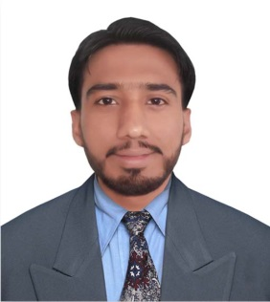
AZHAR
MECHANICAL DESIGN ENGINEER

Language: English, Urdu, Hindi
Current Location: Bur Dubai-United Arab Emirates
Visa Status: Visit Visa
E-Mail: azhar.375178@2freemail.com
Professional Summary

Design engineer with 2+ years’ experience in CAD modeling and product development combination of well-rounded developed skills in mechanical design and product management. A collaborative team player with a track record of delivering multiple, concurrent projects in fast-paced environments
Seeking opportunity to use expertise in drafting and modeling to design value added solutions to drive productivity as well as developing technical drawings, plans, building prototypes for testing purposes and making mechanical improvements in projects to drive production efficiency though qualitative analysis and process re-design
Core Competencies

Professional Experience
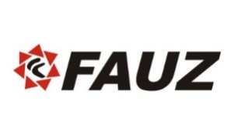
Assistant Manager Project’s | Engineering/Design
Mechanical Design Engineer February 2016–Present
FAUZ Engineering Limited-Lahore, Pakistan
- Developed and monitored product design and production for: Pressure vessels, Heat ex changers, Structures, power tools structure design, machine design and manufacturing techniques and interested in manufacturing, management and designing while maintaining quality standards and regular test runs.
- Coordinated all the blueprint and manufacturing/production issues of the product design.
- Analyzed, tested and studied new mechanical design theories, new lines of products/devices and methodologies in order to make recommendations for the organization.
- Prepared and conducted provisional tests, maintenance of installed equipment and performed risk assessments.
- Analyze Structures and generate structure feasibility reports.
- Purpose counters design if current structure is not meeting the need of required codes and standards.
- Cost Estimation by finding material consumption using CAD software.
- Analysis of mechanical systems, including Finite Element analysis for structural, fatigue, thermal and vibration.
- Design and optimization of mechanical components and structures.
- Read and interpret blueprints, technical drawings, schematics, and computer-generated reports.
- Research and analyze customer design proposals, specifications, manuals, and other data to evaluate the feasibility, cost, and maintenance requirements of designs or applications.
- Develop manufacturing drawings in accordance with applicable standards
Activities
- 2D Drawings
- 3D Modeling
- Generation of Isometrics
- General Arrangement Drawings
- Modeling of Skid Mounted Equipment
- Conceptual equipment layout drawings for process plant reflecting the process constraints.
- Process data sheets for equipment
- Review of drawings for machinery & other brought-outs
- Updating of P&ID’s based on detailed engineering
- Scheme for the erection of equipment in consultation with site engineer
- Preparation of drawings for statutory approvals
- Preview of vendor drawings

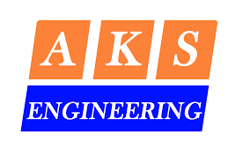
Trainee Engineer June 2015-January 2016
A. Karim and Sons Engineering (PVT) Ltd-Karachi, Pakistan

- Led project scheduling and budgeting to successfully and quickly complete engineering projects.
- Performed on-site field surveys and wrote technical narratives in an efficient and timely manner.
- Developed cost estimates, procured equipment and tracked construction progress to efficiently complete large scale projects.
- Oversaw fireproofing of equipment and structure.
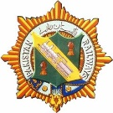
Internee Engineer July 2014-August 2014
Pakistan Railway Carriage Factory-Lahore, Pakistan

Personal Skills

- Strong communication skills
- Advanced critical thinking
- Complex problem solving
- Works well in diverse team environment
- Troubleshooting expert
- Microsoft Office proficiency
- Team leadership skills
- Outstanding interpersonal skills
- Strong Creativity Skill
- Adaptability and Collaboration
- Highly energetic and self-motivated resource
- Time and Resource Management

Languages

English: Fluent in speaking, reading and writing comprehension
Urdu: Fluent in speaking, reading and writing comprehension
Punjabi: Fluent in speaking, reading and writing comprehension

Academic Record
2011-2015 Bachelor of Mechanical Engineering (3.32 CGPA) 82%
COMSATS Institute of Information Technology, Sahiwal
2009-2011 Faculty of Science (F.Sc) (732/1100) 67%
Government Post Graduate College, Sahiwal
2007-2009 Matriculation (696/1050) 66%
Government High School, Rajowal

Academic Projects

Shell Eco-marathon Asia, Designing and Fabrication of Fuel Efficient Eco- friendly car

- Assisting all activities including design, fabrication and testing of all parts.
- Preparation of daily Look ahead Plan, adding resources and closing Work orders generate monthly reports and work order status to Shell International.
- Contribute to continuous improvement in HSE performance by ensuring safety and environmental standards are followed within the workplace.
- Departmental daily meeting with all stakeholders to discuss progress of ongoing fabrication work and monthly Presentation to management.
- Follow and implement of Shell HSE Policy with respect to Maintenance activities
- Completed the CAD model to the fabrication of the vehicle including all technical work
- Served as the Team Manager and earned sponsorships for the university team
- Worked as chief content writer of team’s website, proposals, brochures, flyers etc. for one year
Research Work

- Research on "Aerodynamic optimization of airfoil using high lifting devices."
- Research on “Modeling and verification of single slope solar still using ANSYS-CFX”
- Steady and unsteady state thermal analysis of different cross section fins using CFD.
- Research on making the “Flow over airfoil more streamline and drag reducing by adding rib lets and additional streamline making and drag reducing device.”
- Study on “Flow Modeling in a Porous-Fluid Domain using ANSYS CFX”, because Porous fluid problems are encountered in lots of engineering applications, in soils, in food and in filters.

Awards and Certifications

- Award and Certificate of “3rd position in All Pakistan ASME International Mechanical Engineering Convention 2015 GIKI Chapter Research Paper competition.”
- Appreciation Certificate from SAHIWAL CHAMBER OF COMMERCE AND INDUSTRY (ISO Certified) for making first Fuel Efficient car in Sahiwal.
- DICE AUTOMOTIVE 2014 Competition School of Mechanical and Manufacturing Engineering DICE Foundation, USA

