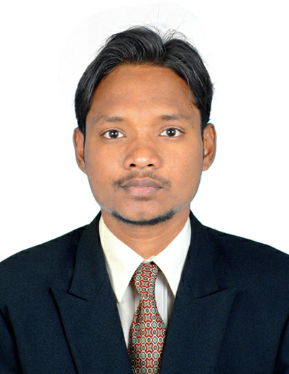
RESUME

IQBAL
E-mail iqbal.375184@2freemail.com
Visa Status: On Visit (till 6th March 2018)

- CAREER OBJECTIVE:

Having 3+Years of experience in various sector in which 2 years of banking process, 1 year of IATA based Tours & Travelling ticketing agent & 7 months experience of Event coordinator. Aim to perceive a challenging, rewarding and satisfying career. These allow me to grow with organization both personally and professionally to provide worldwide career path in this rewarding arena.

- COMPANY PROFILE & WORK EXPERIENCE:

- IBM India Pvt Ltd. SA br. Bangalore., Karnataka
- Worked as a ‘Event Coordinator' in IBM India Pvt. Ltd., from April 2017 to Dec’ 2017, Bangalore. India

Responsibilities:
- Arranging event while following all company and safety standards
- Creating an agreement and budget with the client
- Communicating all budget, space and vendor progress with the clients
- Communicating any problems that arise in an upfront manner with the client
- Maintaining communication with any outside vendors contracted for the event
- Welcoming all guests and address all needs
- Preparing and executing a detailed outline of the event needs
- Arranging meeting space, lodging for guests, food and drink, music, visuals and any other needs the client has.

- HCL Technologies. Ambattur Br., Chennai. TN
    - Worked as a ‘Business Analyst (Banking process) in HCL Technologies from Feb-
2015 to Aug’ 2016, Chennai. India
    - Client : Bank of Ireland (UK).
Responsibilities:
    - Ensuring the smooth running of basic banking transactions.
    - Answering any financial and banking queries.
    - Verifying customer data to detect and identify financial malfunctions & fraudulent.
    - Opening / Closing bank accounts for individual customers as per their request.
- Handling account opening process to the customers and validating the documents.
- Anti-money laundering documents verification.
- Updating the records (To operate their accounts).
- Solving UK customer’s queries regarding all kind of account related query like account opening (Fixed term deposit, current account and saving account).
- Account closure procedure and formalities to the customer’s all kind of banking account, withdrawal request etc.,

- Bhagiya Travels Egmore, Chennai, TN.

Duration : Sept-2013 to Aug-2014
Role : Ticketing Agent

- Arranges reservations and routing for passengers at request of Ticket Agent.
- Examines passenger ticket or pass to direct passenger to specified area for loading.
- Plans route and computes ticket cost, using schedules, rate & books.
- Assists passengers requiring special assistance to board or depart conveyance.

- Avon Global Solution, Chennai
Client : Citibank Contact Center.
Duration : Feb-2013 to Aug-2013
Role : Customer Support Executive.

EDUCATIONAL QUALIFICATION:

B.B.A - Bachelor of Business Administration, from Thiruvalluar University. Chennai.
Year of Completion: 2011 with securing 60% of Marks.

IATA/UFTAA Foundation Course, Montreal, Canada. Mar- 2012.
Basic Diploma in CRS (AMADEUS)

D.C.A - Diploma in Computer Application, from Institute of Technology, Chennai
Year of Completion: 2010 with securing 82% of Marks.

COMPUTER SKILLS:
Operating System : Dos, Windows Xp, Windows Vista, Windows 7 Home
Microsoft Office : Version: 2003, 2007 MS Word, MS Excel, MS Power Point,
Knowledge of : Installation of software and Computer Hardware

ACADEMIC PROJECT:

Duration: 1 month
Project Based On: Automobile Industry

Description:
This project is covered on: Taking measures on total assessments of an Automobile Industry(four wheeler) based on TATA MOTORS, which deals with fundamentals of industrial manufacturing models such as Indica, Santro, Zen estilo etc.,

The main objective of this project is
To know the market strategy of TATA Motors in automobile industry,
To know the consumer behavior for purchase of four wheeler
To analyze the customer satisfaction,
To analyze the SWOT and to know the consumer feedback.

Also this project covers the total Sales Interpretation on different region of the country which has mainly focus on largest consumer product and sales turnover on the specified region of the country.

- ACHIEVEMENT:

Received a certificate of Achievement for successfully completed Amadeus Basic Functionality Course from AMADEUS, CHENNAI
Received a certificate of Star Performer for the quarter in HCL Excelencia Premio-2015

- STRENGHTS:
- Industrial experience of Customer Care.
- Having 18 months of experience in the field of international banking.
- CRS (Amadeus) working and professional knowledge of booking/ reservation of air
- Tickets and travel related documents.
- Ability of work in various responsibilities- Sales and Customer Support.
- Languages known: English, Hindi, Tamil & Urdu.

- PERSONAL PROFILE:
Name : Iqbal
Date of Birth : 10th May1991
Gender : Male
Marital Status : Single
Nationality : Indian
Languages Known : English, Tamil, Hindi, and Arabic.
Visa Status : On Visit (Till March – 2018)

- DECLARATION :

I declare that the information and facts stated above are true and correct to the best of my knowledge and belief.

DATE :
PLACE : Dubai.
Yours sincerely,

IQBAL

