CURRICULUM VITAE

PERSONAL INFORMATION
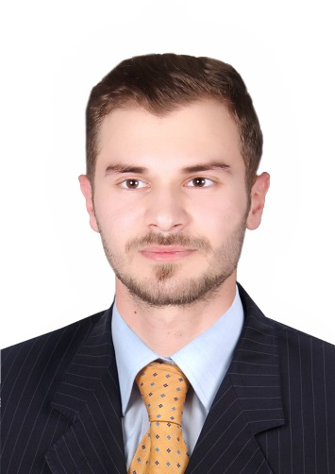
Name: Modar
Date of birth: march18, 1992
Email: modar.375192@2freemail.com

EDUCATION
Bachelors in science of physics, physics department, college of education for pure sciences, Tikrit University, Iraq.2014.

WORK EXPERIENCE
- Camp Coordination Camp Management (CCCM) team supervisor (Dec-2016 to Oct-2017)
At Terre des homes (a Swiss humanitarian organization -Tikrit office- Iraq).
Responsible for community liaison team activities, and community center activities.
- Collect data from field activities and prepare regular reports on CCCM activities.
- In charge of community center activities like handicrafts courses for young adults and awareness lectures and meetings with community figures.
- Lead and carry out assessment to identify context based appropriate CCCM activities for the community.
- Ensure implementation of the activities in line with CCCM global standards and relevant national and international standards, code of conduct, and humanitarian principles.
- Attend and take part in the community meetings necessary for passing on information.
- Maintain liaison with the other international organizations and community based organizations at the community level to ensure their cooperation and coordination for effective implementation of the program.
- Worked in logistics field like taking quotations from suppliers and, making purchase requests to the manager to supply items to the CCCM team.

- Database clerk (Aug-2016 to Dec-2016)
At Terre des homes (a Swiss humanitarian organization -Tikrit office- Iraq).
- Compiling families’ information from mapping team, and children information from the child protection team, and arrange this information in lists.
- Translate information from Arabic to English.
- Provide Arabic and English lists to the distribution team.

- Distribution monitor (Aug-2016)
At Terre des homes (a Swiss humanitarian organization -Tikrit office- Iraq).
- Following up the implementation of distributing items to the displaced people and maintain the smooth and proper work.

- Worked as volunteer in a local team to help poor and displaced people (Jan-2016 to June-2016)

Skills
- Languages:
- Arabic: native language.
- English: very good speaking, listening, reading, and writing.
- Very good computer skills (MS office word and excel) and the ability to learn using any new software and application very quick.
- Excellent leadership skills.
- The ability to work under pressure and problem solving.
- The ability to learn anything very quick.

