Curiculum Vitae
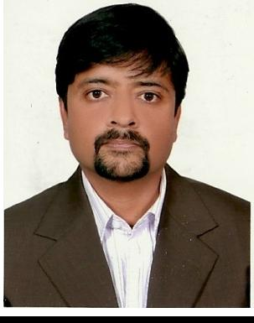

Personal Detials:

Name: Muhammad

Age : 38
Visa Status: UAE Employment Visa

Marital Status: Married

Driving License: Valid Vehicle Driving License.- UAE

Contact Details: Muhammad.375199@2freemail.com

Objective:

A challenging and exciting career in an Organization in which I can participate

Actively in the Project Sales & Execution plan and assist in nurturing it into a prestigious Company

Specialties

Project Sales, Budgeting, Project Execution, Consulting, Contract Management, Cost

Control, Customer Relation, Inventory Management, Project Management, Meeting facilitation, Microsoft office, Negotiation, Optimization, Policy Analysis, Procurement

Progress, Quality Control, Reports, safety & Troubleshooting.

Experience

➢ Etihad Global Hospitality : (Sales Executive & Execution Supervisor)

September 2012 – Till Now

- Identifying new hotel projects & brings the sales in the company.

- Handling the complete procurement till execution of the projects & maintaining project Report.
- Preparing feasibilities & budgeting of future projects
- Liaising with suppliers & maintaining a data bank of the suppliers
- Liaising & managing the client / end users.

➢ Al Rayan Project Contracting: (Project Sale & Execution Supervisor)

August 2009 – August 2012

- Identifying new hotel projects & brings the sales in the company.

- Handling the complete procurement till execution of the projects & maintaining project Report.

- Preparing feasibilities & budgeting of future projects
- Liaising with suppliers & maintaining a data bank of the suppliers
- Liaising & managing the client / end users.

➢ Thuraya Turnkey Projects: ( Projects Sales & Execution Supervisor)

January 2007 - July 2009

- Bring sales of the commercial hotel projects.

- Explore new business opportunities local as well as overseas
- Managing the day-to-day Operations of the Factory and the Execution Department .

- Analyzing of material requirements and planning procurement based on the priority and Project deadlines.

- Implementing quality and cost control system in the factory

- Monitoring the Project plan and resolving technical issues with the Consultants and Clients

- Negotiating with Sub Contractors and Suppliers
- Attending Meetings with Client & Consultant for troubleshooting
- To implement efficient cost control systems in relevant departments so as to adhere to the budgeted cost.

- Empowering staff to take up more responsibilities thereby encouraging them to move forward.

- Coordinating approvals of PO’s release from Procurement Department.

➢ Golden Motors Telecom

(Inventory Controller & Warehouse In charge) Sharjah

Feb 2004 - Sep 2007

- Maintaining the inventory sheet segregated to various items

- Maintaining the Reordering the specific products through Purchase department
- Showroom visits for Inventory
- Handling the complete Warehouse
- Managing the delivery & distribution team
- Maintaining delivery Schedules

➢ Mobility FZ LLC Dubai: (Merchandiser)

April 2003- September 2004

- Best employee awarded for Gitex Exhibition

- Maintaining the stock availability in the warehouses of corporate clients
- Providing Guidance to the customers
- Introducing new products of the company in the corporate sectors
- Worded in Collaboration with Jacky’s, Jumbo, I2, Sharaf DG, E-max, Carrefour

➢ Education

MCS (Master in Computer Science – Preston University, Karachi Pakistan)
BCOM (Bachelor of Commerce – Karachi University, Pakistan)
Diploma of Computer Software – Petro Man , Karachi Government of Pakistan
Diploma of Computer Hardware – Petro Man, Karachi Government of Pakistan

➢ Interests

Balling
Martial Arts
Board Games

Movies

