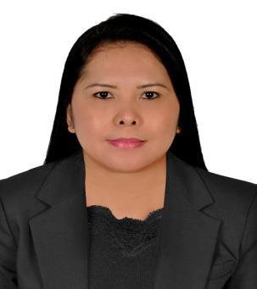
MICHELLE

Email: michelle.375202@2freemail.com

Career objective

To be a part of a company where I would be an asset by exercising

professionalism in works, utilize and enhance my ability and knowledge to the company I will serve.

Key qualifications

- 4.8yrs experienced as a Customer Service Representative / Cashier

- 10yrs experienced in Customer Service

- Computer Literate

Work experiences

ALFALAH EXCHANGE CO.

Sharjah, UAE

Customer Service / Cashier
Dec. 30, 2012 – Aug. 28, 2017

- Buy and sale foreign currencies.

- Accept cash/cheque for all transaction payments.

- Transfering money through Telegraphic Transfer and Online Money transfer through Western Union, Express Money, Instant Cash, Transfast, Leader, Himal Remit and IME.
- Check and balance cash at the end of the day.
- Encoding and releasing Philippine transactions.

- Ensure all the transactions are processed as per Anti Money Laundering, KYC procedures and prescribed guidelines of the Central Bank.
- Do marketing for company products like wps, bank transfer / online money transfer, Etisalat and credit card payments.
- Keep filing daily monetary reports, documents and circular memo.
- Handling customer complains and inquiries.

- Reconcile online transactions.

DANIEL HECHTER/BALMAIN

(Paris Group Int’l.)
Abu Dhabi Mall, Abu Dhabi U.A.E.
Cashier

April 19, 2006 – March 5, 2009

- Greet the customers.
- Accept cash and credit card payments.

- Deal with customer complain and inquiries.

- Process merchandise returns and exchange.

- Reconciling total sales at the end of the day.

- Prepare daily, weekly and monthly report of transactions

EDUCATIONAL BACKGROUNDs

- BACHELOR OF SCIENCE IN INDUSTRIAL EDUCATION (Computer Major)

NUEVA ECIJA UNIVERSITY OF SCIENCE & TECH. Cabanatuan City, Philippines

Year: 1997 - 2001

- BASIC AND ADVANCE AUTOCAD

PROVINCIAL MANPOWER & TRAINING CENTER Cabanatuan City, Philippines

Year: 2009

Personal details

Nationality Gender
Civil Status Visa Status Expiration

: Filipino
: Female
: Married
: Tourist

: 28-01-2018

I am fully confident that I can handle any challenging job. If you would give me a chance to serve your company I assure you that I will prove myself by offering my abilities and experience to your esteemed organization to satisfy and meet your expectations in an employee.

Truly Yours,

MICHELLE

