Resume

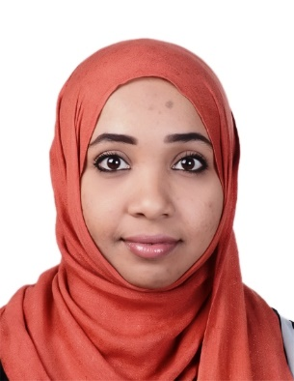

Name | Huda
Nationality | Sudanese.
Gender | Female.
Religion | Muslim.
Marital Status | Married.
Language | Arabic (Mother Tongue) – English.
Email | - Huda.375214@2freemail.com

Qualification & Education

2013 – 2015.
- MSC. Biology. (Immunology) / Sudan Academy of Science

2004 – 2007.
- BSC. Medical Laboratory. (Clinical Chemistry) / Sudan University of Science & Technology.

2001 – 2003.
Almanar Aljadeed High Secondary Schools. Sudan

2001 – 2000.
Um Ayman Preparatory Schools for Girls. Al Ain-UAE

1998 – 2001.
Amorya Primary Schools for Girls. Al Ain-UAE

Experiences

10/5/ 2015- Till 9/6/ 2016
Research Lab technologist trainee -Africa City of Technology / department of Immunology - Khartoum-Sudan

1/3/ 2012- Till 1/8/ 2013
Med. Lab. Specialist -Antalia medical centre / department of Immunology
Khartoum-Sudan

3/8/ 2008 – 5/6/ 2010.
Med. Lab. Tecnologist - Alghofran Medical Centre - Khartoum-Sudan

5/2/ 2008 – 5/2/ 2009
Med. Lab. Tecnologist and lab teaching assistant as National Duty –
Alrebat National Hospital - Khartoum-Sudan

Researching Skills

Common Molecular Biology Techniques:
- DNA Sequencing Technology
- Polymerase chain Reaction (PCR)
- Hands on most of sophisticated instrument used in pharma/biotech
Molecular Modeling and Drug Designing Skills
Molecular Modeling Tools:1
- Chem3D Ultra Version 8.0 - ChemFinder Ultra Version 8.0
- DeepView/Swiss-Pdb Viewer Version 3.7
Molecular Docking Tools:
- GOLD Version 2.1 - Argus Lab Version 4.0.1
Molecular Visualization Tools:
- Mercury Version 1.3 - RasMol Version 2.7.2.1
- DeepView/Swiss-Pdb Viewer Version 3.7
Sequence Analysis Tools:
- Clustal X Version 1.83 - Clustal W Version 1.83
Analysis Packages:
-DNA sequencing analysis tools

Computer skills:

- Whole Microsoft package (Power point, word, excel…etc) and a good internet experience.
- Ability to interact effectively with people.
- High skills on negotiation and communication.
- Hard worker with high tolerance to work pressure.
- Very high interest in learning and a desire to succeed.
- Hands-on self-starter.
- Good Documentation and presentation skills.

