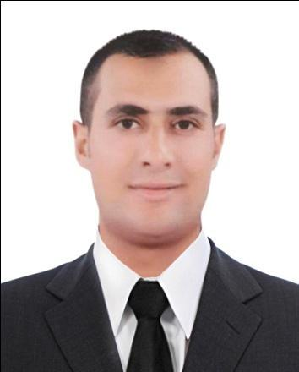

Name : Omar

E-mail : omar.375217@2freemail.com

Nationality : Egyptian

Residency : UAE

Birth date : 25/11/1991

Driving license : EGYPT

Martial status : single

Objective

I am civil engineer looking for a position in civil engineering company

Languages

Arabic : native

English : excellent

German : beginner

Skills

Good convincing and negotiation skill.

Excellent Presentation skills. .

Excellent Project Management skills.

Good in MS OFFICE such as Word, Excel, and Power Point, Outlook.

Quick learner and self-motivated.Problem solving and Decision making.

Work in Team Work and an outgoing personality.Turning ideas into action Excellent organization, communication .

Sharing viewpoints openly and directly with others. problem solving skills. Ability to exercise discretion in confidential matters.&Getting things done quickly

Experience

worked at Rowaad modern engineering company at GabalElzait project which was establishing rft concrete bases for windmills and roads as a site engineer.

Job responsibilities :

1-Quantity surveying

2-Preparing payment certificates for subcontractors

3-Preparing take of quantities

4-supervision on site work

Training history

The Arab Contractors company at Elmonofiya 2012

EamarAldelta company at Elgharbiya 2013

and Elshams company at KafrElsheikh 2014.

Other:hadAutoCAD 2d,SAP,design and the implementation of civil works and architectural interior finishes courses.

Attended the International petroleum and geosciences conference 2014 in Giza.

Education

Bachelor`s degree in civil engineering , faculty of engineering ,Tanta
university , Egypt.
Graduation year: 2015.
Graduation project: structure analysis…grade : very good

REFERENCES

Will be furnished upon request

