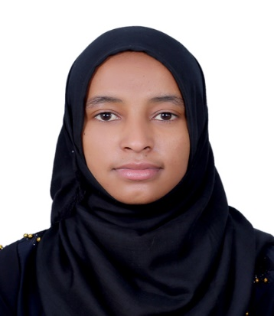
Dr. MEKIA (M.D)
Email: mekia.375220@2freemail.com

Career profile
Highly motivated, clinically competent, and MOH licensed general practitioner with 4 years of experience caring for patients with a range of cultural backgrounds. I am a hard worker and a team player with the ability to work with the multicultural team. Looking for suitable positions in private or government sector, in which I can help people maintain their health and quality of life.
Education
- Doctor Of Medicine (M.D), July 2013, Hawassa University College Of Medicine And Health Sciences, Hawassa, Ethiopia.
  - I graduated with distinction
Medical Licensing
- MOH License- as General practitioner (Ministry of Health, UAE), August 2017
- Health professionals registration and licensing certificate- Federal Democratic Republic of Ethiopia The Food, Medicine, And Healthcare Administration And Control Authority, October 2013

Certificates and Training

- BLS (basic life support) certificate, July 2017
- ACLS (Advanced Cardiac Life Support) certificate, May 2017
- Comprehensive TBL/HIV (Tuberculosis, Leprosy and Human Immunodeficiency Virus) management training, December 2016
- Programmatic management of drug-resistant TB (MDR TB) training, May 2014

Experience
- October 2013 up to now
General practitioner, Zewditu Memorial Hospital, Addis Ababa, Ethiopia.

Responsibility
  - worked on a rotational basis in Medical OPD, Emergency, Adult medical and surgical ICU, GYN/Obs, and Pediatrics departments
  - Examine patients, document their medical histories, order laboratory tests,
X-rays, and other diagnostic procedures
  - Prescribe and administer medications and treatments, consult a senior medical practitioner if needed
  - Admit patients after consulting with senior medical practitioners
  - Perform minor procedures such as primary closure techniques (suturing), fracture stabilization (immobilization by POP), IV cannulation, Nasogastric tube placement, digital nerve blockage, removal of superficial foreign bodies, nasal packing for epistaxis, punch biopsy, ECG and simple interpretation, lumbar puncture, urinary catheterization, and CPR
  - Accompanied seniors residents and consultants on morning and afternoon ward rounds
Key Skills

- Reliable medical knowledge and diagnostic skills
- Able to work in a team or individually
- Ability to remain calm under pressure and excellent bedside manner
- Good communication and time management skills
- Able to deliver the highest standards of one-to-one care to meet any individuals needs

Hobbies

- Reading books like Quran, watching TV and movies, and also I love exercising especially cardio.

Language skills
- English –excellent on writing, speaking, listening and reading
- Amharic –excellent on writing, speaking, listening and reading
- Arabic – good on writing and reading

Personal Information
- Gender: Female
- Date of birth -13/07/1989
- Marital status-Married
- Religion – Islam
- Nationalities –Ethiopian
- Visa status- visit visa

