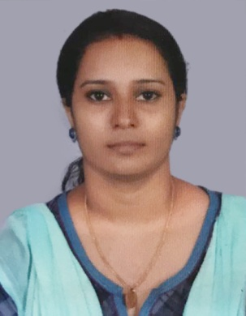
RESUME

Pillai

E-mail: Pillai.375222@2freemail.com
CAREER OBJECTIVE
Like to work in a challenging environment where my skills are fully utilized, where I can make a difference
PERSONAL STRENGTH
- I get along with different types of people with positive attitude
- Responsible person with good organizational and communication skill
ACADEMIC QUALIFICATION
- B.Sc Biotechnology (Bangalore University)
- 12th ( Sarvajinik Vidyalaya, Daman, Gujarat Board)
- 10th ( Institute Of Our Lady Of Fatima, Daman, Gujarat Board)
COMPUTER KNOWLEDGE
- MS Office
- COPA (Computer Operating & Programming Assisting)
PERSONAL DETAILS
Name : Pillai
Visa Status : Residence ( Husband’s Sponsorship )

DOB : 6/11/1988
Sex : Female
Marital Status : Married
Nationality : Indian
Religion : Hindu

LANGUAGES KNOWN
- English
- Hindi
- Malayalam (only to speak)
- Gujarati
PERSONAL ATTRIBUTES
- Able to comprehend fluency in English and Hindi
- Ability to learn new things
- Hardworking and give my best in whatever I do
- Have good knowledge in computer
WORK EXPERIENCE
- Leo Public School, Kollam
- One year experience in Vodafefone collections
- One year experience in Airtel collections
- Currently working in Brook International School, Kollam
ACHIEVEMENTS &EXTRA CURRICULUM
- A participant in Nationals as a badminton player
- Awarded as best teacher in currently working school
DECLARATION
I do hereby declare that the information given above is true to the best of my knowledge and belief. If I get this opportunity I assure you that I will work sincerely to meet your expectations.

