CURRICULAM VITAE

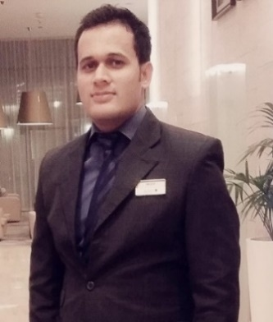
Mohammad

.
Date of Birth : 3rd April 1990.
Nationality : Pakistani
E-mail : mohammad.375258@2freemail.com
License : UAE Guest Buggy Car Driving License

Carrere Objectives:

Positions, which can hone up my skills, invigorate an urge to perform and achieve goals keeping in mind the aesthetics of Professionalism. A job that allow me for greater achievements and which would effectively apply my professional skills.

Professional Working Experience

In Front office, Housekeeping & F & B

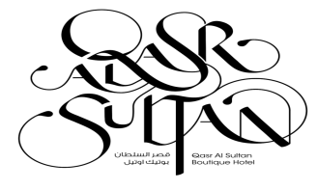
Qasr Al Sultan Boutique Hotel FNB Concept
(Preopening Villa Hotel)

3 Month worked as a Waiter.

Designation: Receptionist – Part time Waitering
Location: Dubai U.A.E
Tenure: Aug 2017 Present

Radisson Blu Hotel Dubai Marina

Designation: Concierge In charge
Location: Dubai, U.A.E
Tenure: March 2014 to April 2017

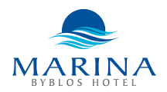
Marina Byblos Hotel, Dubai Marina.

Designation: Housekeeping Supervisor
Location: Dubai UAE
Tenure: January 2011 to March 2014
Trainings attended

Reception, Night Audit, Operator, Housekeeping Supervisor, Firefighting, Yes, I Can Attitude, Online Rezportel Training. Chemical acknowledgment, OJS Trainer in Rasidore.

Fire Fighting Training from Dubai Police Academy.

- Having Basic Fire Safety Certificate from Safer fire safety consultancy Dubai.
- Well trained to fight against the fire.
- Well trained to evacuate the guest and show them a safe way to exit.
- Communicate to all and make sure everyone is safe in the premises.

Leading Yes, I can:

- Radisson Blu Dubai Marina, Dubai, United Arab Emirate. December 2015-

Online Course Trainings on Rezidor Web Portal:

- Radisson Blu Dubai Marina, Dubai, United Arab Emirate. September 2014 -

Achievements:

- Certificate of Employ of the Month got from Radisson Blu Hotel Apartment. Given on February 2016.
- Certificate of recognition of Marina Byblos Hotel award of best price value hotel (silver and gold) given at 14th May 2012.
- Certificate of Employ of the Month got from Marina Byblos Hotel given on February 2013.
- Certificate of computer office automation from Commercial Training Institute of Pakistan given at 25th Sep 2005.

Previous Experience in Pakistan

Worked as a Housekeeping Supervisor in Islamabad Marriott International Hotel in Pakistan Rawalpindi in December 2009 to December 2010.

Academic Qualification:

- Bachelor Degree (Arts) passed in 2009 from HAZARA University Abbottabad Pakistan

IT and Linguistics

- MS-Office.
- Outlook, Scalix
- Internet Applications
- Adobe Photoshop
- Opera management System.
- Printing, Scanning, Faxing, Composing

Spoken Languages:

English, Advance
Arabic: Basic
Urdu, Hindi, Native

ADDITIONAL KNOWLEDGE

Preopening Experience.
Honey Moon, Anniversary, Birthday Bed Making.
15 styles of Towel Art.
10 Types of Napkin Folding.

