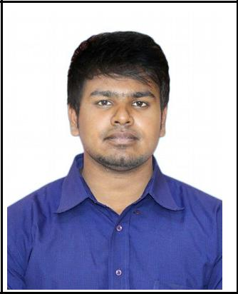
RESUME

Michale
Michale.375270@2freemail.com

Objectives:

Seeking placement in your esteemed organization where my technical
Skills and available potential are effectively utilized for the better development of the firm.

Technical Qualification:

Course : B. Tech in Electrical and Electronics Engineering.

Institute : Karunya University, Coimbatore.

Percentage& Class : 59%

Year of passing : 2017

Educational Qualification:

Course : +2

Institution : ST. Stella's Matric Higher Secondary School.

Percentage& Class : 74% & First class with honors.

Year of passing : 2013

Additional Skills:
MS Office (Excelc PoweoPoint c Wood)Po Basic computeo toouble shooting
Eneogetic poesentation skill Sales management

Additional courses:
EMBEDDED DESIGN oelated)P toaining foom Uniq technologies, Chen-nai.

Attended PCB Design workshops in IIT Bombay.

Area of interest:

Control of Electrical Machines. Automation controls.

Maoketing Electoical pood)Pucts.

Experience:

Worked in TEXMO INDUSTRIES, Coimbatore from 7th May 2017 to 10th Nov 2017 as Plant Maintenance Engineer Trainee (6 Months).

Key Functional Responsibilities:

Utility maintenance & machine shop handling
Analyzing all breakdowns & carrying out requisite step for recurrence prevention. Im-plementing corrective and preventive action.
Spare parts inventory management
Ensuring 100% availability of critical spares in stores.
Maintaining the machine manuals with proper handling systems.

Trouble Shooting and Maintenance Knowledge in:

CNC based (FANUC Series)
Pneumatic Systems & Hydraulic Systems Lubrication systems
EB units and EB billing calculate & corrective action every month Maintained the 5S preventive maintenance works.
All Types Of Motors And Starter
Daily maintenance records where properly checked. Panel board assembly knowledge.

Machine Handles:

HWACHEON HI-TECH(TTC- 8,300L,300,VTL550.VTR550,TTC10) , Feeler, HMT STC-25,STATOMAT CNC Winding, CIRCULAR WELDING, PREWO CNC HYD PRESS, PARAGON CNC GRINDING, CNC CIRCULAR SAW CUTTING, HMT G-17 GRINDING CONV,PARISHUT GRINDING, ATLASCOPCO VSD Compressor. DIE-CASTING HMT, BALANCING m/c.

Personal Information:

Date of birth : 23/11/1995

Marital status : Unmarried

Languages known : Tamil & English(R/W/S), Hindi(R/W)

Declaration

I shall be grateful, if you give me opportunities to serve in your organization I assure you Sir/ Mam, that I will discharge my duties to the best of my ability and would certify prove worthy of your selection. I hereby declare that the particulars mentioned above are true to the best of my knowledge.

Place: yours sincerely,

)

Date:

