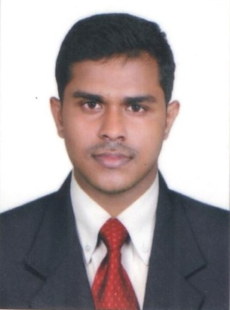
CURRICULUM VITAE

MIDHUN
E-mail: MIDHUN.375279@2freemail.com
OBJECTIVE
Looking for opportunity in automobile technician where I can use my scientific and communicative abilities help to contribute the growth of company in automobile industry along with my career.
PROFESSIONAL EXPERIENCE
Senior technician September 2017
Kairali Ford Thrissur Kerala
March 2014 to September 2017
QUALIFICATION
National council for vocational training (2011-13)
R ganesh memorial victory private industrial training institute ollukkara, thrissur
HONORS AND AWARDS
- Ford level 2 training
- Ford level 1 training

PROFESSIONAL SKILLS
- strong customer service skills
- strong communication skills
- good diagnostic skills
- problem solving skills
- strong technical aptitude
- up-to-date technology
- leadership
- certified
- personal tool inventory
- solid work ethic
PERSONAL DATA
Date of birth : 10 march 1993
Marital status : single
Nationality : Indian
Languages : English Malayalam
Visa status : visiting visa
Driving license : Indian only
DECLARATION
I hereby declare that the information furnished above is true to the best of my knowledge and belief

