Victor
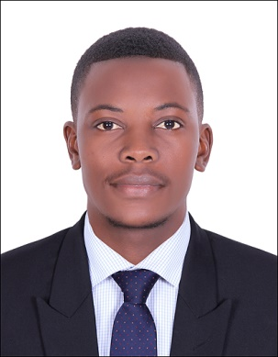
Email: victor.375289@2freemail.com

Professional Summary
Resourceful and self-directed teaching professional with over 3 years experience and great interest in fostering high school students’ learning skills and social growth. Strong passion for working in an environment conducive to literacy by employing dedication and motivation. Skilled in designing high school curriculum targeted at meeting the need of students with varying abilities and backgrounds.

Objective
To seek employment as a Humanities or Social Studies teacher at a learning institution renowned for its provision of superior education and to keep growing as an educator while sharing my passion for Geography with high school students.

Skills
- Extensive experience teaching Humanities to high school students, at all levels.
- An outgoing, dynamic, pleasant personality and teaching style.
- Excellent public relations skills, communication skills, and interpersonal skills
- Experience as advisor to various student-run clubs
- Experience and strong desire to incorporate a multidimensional, multicultural curriculum that links geography, the arts, history, language, culture, and society
- Experience and knowledge about teaching effectively to accommodate various learning styles
- Ability to foster a lively, enthusiastic, and positive classroom learning environment
- Detail oriented
- Ability to organize and prioritize workload effectively
- Flexible and adaptable to change
- Strong quantitative, critical thinking, and analytical skills
- Ability to work independently or in a team environment

Work History

Geography Teacher High Achievers Education Centre 07/15 – 09/17
- Taught Geography and Environmental Science classes to a diverse array of students of varying ages and abilities
- Created multicultural lesson plans
- Incorporated technology into the classroom
- Planned and organized hands-on activities that encourage active student participation, involvement, and team work
- Advisor for Geography Club, focus on fostering student leadership and organizing social and community events
- Maintained an orderly, peaceful, and positive learning environment, applying disciplinary measures when necessary
- Incorporating cultural, social, and historical components into the curriculum to diversify and expand learning material
Humanities Teaching Assistant High Achievers Education Centre 01/12 – 08/12
- Assisted the teacher in designing and implementing class curriculum
- Prepared lesson plans
- Extended help to students as and when required
- Handed out material related to subject matter
- Performed substitute duties in the absence of the lead teacher
- Implemented a variety of teaching tools to accommodate all learning styles
- Fostered a positive and safe learning atmosphere

Education
2017 Executive Certificate in Program and Project Monitoring and Evaluation,University of Zimbabwe
2015 Bachelor of Science Honors Degree in Sociology, University of Zimbabwe
2011 High School Advanced Level Certificate, St Faith’s High School

Accomplishments
2016 International Youth Foundation Passport To Success Training Certificate in Professional and Life Skills.

Referee available on request.

