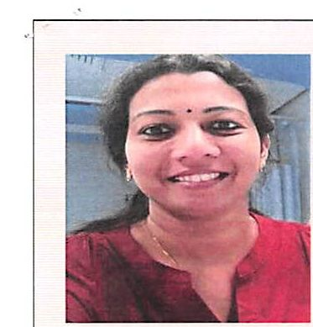

DEEPA CPC, ICD - 10 - CM

Certified Msc Dialysis Technology

Email : [deepa.375299@2freemail.com](mailto:deepa.375299@2freemail.com)

Nationality : Indian

Date of birth : 25/05/1984

Gender : Female

Marital status : Married

Religion : Hindu

Visa Status: Husbands Visa

Languages Known English, Malayalam.

Professional Skills & Certificates

MEDICAL AUDITOR

Certified Professional Coder CPC. ICD-IO-CM

OB.IECT1VE:-

Seeking a MEDICAL AUDITOR / CODER/ /MEDICAL RECORD TECHNICIAN /INSURANCE / MEDICAL RECORDS OFFICER/ MEDICAI SECRETARY /Chart Abstraction Specialist in a hospital / clinic where I can utilize my clinical and medical apparel knowledge, extensive computer skills and strong organizational abilities.

PROFESSIONAL QUALIFICATIONS:

|  |  |
| --- | --- |
| M.Sc Dialysis Technology | * Kerala University * India Hospital Trivandrum * Year: 2004-2006 |
| B.Sc Chemistry | * Kerala University * SNCW * Year: 2002 - 2004 |

Total Work Experience: 11 years

WORK EXPERIENCE SUMMARY:

I) THUMBAY HOSPITAL . Dubai

Durat ion : January 2015 - January 2017 Designation : Medical Auditor Work Section : Mcdical Record Department and Quality Department..

Jobs and Responsibilities.

* Evaluate Medical Records for inaccurate or missing documentation.
* Skilled in DMA/ HAAD/JCI Audits.
* Knowledge of the technical areas of a Medical Record Department including the inpatient and outpatient processing and analysis. Physician's incomplete area.
* Coding E & M Reports with CPT and ICD-10-CM Codes.

Page 1 of 2

«

* Responsible for extrapolating information from claims and medical records to verifying

is billing accurate and follows standard practice guidelines

* Sound Knowledge of JC1 requirements for file completeness.
* Process patient admission and discharge Documents
* Proficient with using coding and medical related soft wares
* Sound Clinical Knowledge and within depth proficiency in medical terminology', abbreviations, anatomy, physiology and pharmacology
* Review records for completeness, accuracy and compliance with regulations
* Compile and maintain patients Medical records to document condition and treatment and to provide data for research or cost control and care improvement efforts
* Release information to process and agencies according to regulations
* Plan, develop, maintain and operate a variety of health record indexes and storage and

retrieval systems to collect, classify, store and analyze information

* Proficient in computer skills - MS word, MS excel.
* Manage the department and supervise clerical workers directing and controlling

activities of personnel in the medical record department

* Train medical record staff
* Excellent in communication, interpersonal and organizational skill

WORK EXPERIENCE IN INDIA

BISHOP BENZIGAR HOSPITAL, KOLLAM , INDIA Duration : November 2011 - November 2013 Designation : Medical Auditor

Work Section : Medical Record Department and Quality

CERTIFICATION: Certified Professional Coder CPC ,ICD-10- CM

This is to certify that the above mentioned information is true to the best of my knowledge and belief.

Deepa

Page 2 of 2