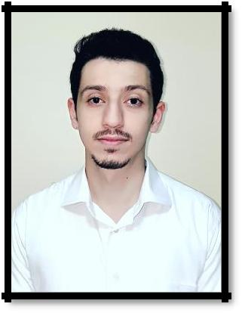
Ahmad
Ahmad.375301@2freemail.com

Date of Birth…………1994/1/15

Citizenship……….….Syrian

Civil Statute……...….Single

___________________________________________________________________________

Objective:

To find a challenge with a developing company where I can develop my skills and help the company to achieve its goals and objectives. Education & qualifications

December 2015 : ALHOSN University, Abu Dhabi, UAE

Bachelor in Architectural Engineering

Professional Experience:

July 2016 – To date: Beam Engineering Consultancy, Abu Dhabi Position Main Architectural Engineer Responsibilities

- Lead architectural production team, reviews contractor shop drawings, specifications, submittals, vendor and shop drawings and coordinates with the work of other disciplines. Working and reporting directly to the Project Director.

- Prepare documents and Architectural drawings, submit them to Abu Dhabi Municipality, and coordinate with the Municipality Engineer to obtain the required approvals.

- Make frequent visits to the municipality to submit documents and hold meetings with engineers to discuss technical and procedural details of the projects.

- Hold meetings with the owners to prepare creative designs and organized landscaping areas for private residential houses and modify them to the client requirements.

- Draft subdivision plans such as electrical, water line, and drainage line layout and details.

- Prepare and develop concept design, design development, production of design documentations (tender and construction drawings)

- Frequently visit sites to check on work progress, ensuring that the project is running on time and to project specifications.

April 2016 to July 2016: National Engineer Office for Engineering & Décor Position Design Architectural Engineer Responsibilities

- Provide sketches, plans, elevations, sections, details and perspectives for many villa projects of different sizes and designs.

- Prepare all project documents in accordance with local codes and international standards

- Review architectural and structural drawings and other trade disciplines and ensure coordination and adherence to all applicable design and building guidelines.

- Work within tight budget parameters and have a good knowledge and understanding of the common Design Regulations and parameters and Design Codes.

- Participate in planning and detailing for projects with interior and landscape packages.

September to October 2015, Monte Bleu Consultancy Abu Dhabi

Internship and Training

Projects and assignments:

- Worked on multi-storey commercial buildings.

- Worked on modifications of designs and additions to apartment buildings.

- Prepared drawings for villas and commercial buildings, including plans, layouts, elevations, and sections and detailed drawings, and prepared them for submission to the Municipality.

- Worked on re-elevations for buildings

- Conducted survey, measurements and design works for reconstruction of old buildings in order to carry out changes and additions with a total new design.

- Learn about building codes and standards and apply them to the design and construction of building.

- Discover new building types and functions, and learn about contract documents and different phases of projects.

Skills:

Computer/Programming Skills:

- Microsoft office (Windows, MS Word, Power Point, Excel)

- Autodesk (AutoCAD, Rivet, 3ds max)

- Adobe InDesign CC

Communication Skills:

- Fluent in Arabic, both spoken and written (Native speaker)

- Proficient in English, both spoken and written.

Personal strengths

- Punctual, ability to work individually and with team.

- Good communicator and fast learner.

- Self-motivated.

- Flexibility and adaptability.

- Work under pressure.

- Commitment to excellence and continuous improvement.

- The consistent search for more knowledge.

Interests

Learning about other cultures, reading and playing sports, drawing & painting, designing, creative works of art.

