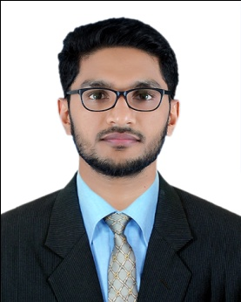
Dr.Naseef (AAPC Certified medical coder, BHMS)
Naseef.375302@2freemail.com

CAREER OBJECTIVE
Want to work as an advancing medical coding professional in a challenging and intriguing working atmosphere with the utilization of adept coding expertise and proficiencies.
EDUCATIONAL QUALIFICATION
Certified Professional Coder (CPC) Certification from the American Academy of Professional Coders (AAPC) 2017
Completed Bachelor of Homeopathic Medicine and Surgery (B.H.M.S) from Dr. MGR Medical University Chennai in 2012
Registered Homeopathic doctor
HSE from State board.
SSLC from State board.
KEY SKILLS/DUTIES
- Proficient skills in the execution of facility coding, physician coding, outpatient coding, and inpatient hospital coding procedures in an exact way
- Inspiring abilities in the operation of Microsoft oriented software applications such as PowerPoint, Excel, and Word
- Informative in different areas like Pharmacology, Anatomy & Physiology, Psychology, Advanced Medical Terminology, and other related medical sectors
- Possesses knowledge of utmost quality related to medical coding methods and guidelines, including ICD-10 CM, HCPCS level II and CPT
- Fabulous typing speed, ranging up to 65 words per minute. Besides, ability to communicate in a professional and impelling manner
EXPERIENCE
- Worked as outpatient medical coder in cure India Health care Pvt Ltd from Oct-2015 to Jan-2017
- Running own Homeopathic clinics at native since 2013.
Responsibilities Handled as Internship
- Carried out duties of a junior Doctor
- Performing the work of coding inpatient, diagnostic ancillary, outpatient, emergency room, observation, and trauma registry services
- Keeping knowledge about various medical coding processes that include E&M, ER, and Radiology.
- Maintaining information about the important terminologies pertinent to medical, physiology, and anatomy subjects
- Attending Investigator meeting & site training meeting.
- Ensuring protocol compliance for all the events and the procedure.
- Identifying potential eligible patients.
- Assessment of inclusion & exclusion criteria.
- Participation in informing the patients about clinical trials.
- Participation in obtaining informed consent.
- Evaluating patient status for safety and assure optimum health care.

AWARDS AND ACHIEVEMENTS
Attended Medical Seminars
INTERESTS
- Playing and watching volleyball.
- Interaction with new people.
STRENGTHS
- Excellent communication skills.
- Good knowledge of clinical practices and protocols.
- Hardworking.
- Motivated.
- Optimistic.

DECLARATION
I do hereby declare that the above given statements are true and correct to the best of my knowledge

