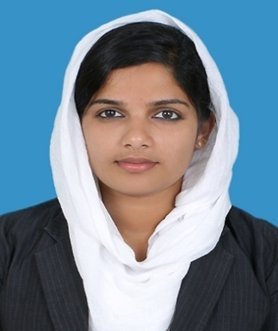

HASEENA
HASEENA.375310@2freemail.com
CAREER OBJECTIVE

To be a part of progressive organization and to work with a team for achieving the organizational goal thereby developing my skills and gaining satisfaction in all aspects

PROFESSIONAL EXPERIENCES

Period: 8 April 2016-2nt may 2017
Venue : Flora hospitality Dubai
Designation: Guest relation associates
Job description:
- Handed over Receive from night shift
- Welcomes visitors by greeting
- Answering the phone calls and referring inquiries
- Directs visitors by maintaining employee and department directories, giving instructions.
- Receiving and sorting daily mail
- Update calendars’ and schedule meetings
- Keep updated records of visitors
- Perform other clerical duties such as filing, photocopying, transcribiling and faxing
- Follow up with the guest reservation

Period: 1st january2015-8 march 2016
Venue: Berggren hotels and resort(keys hotel kochi)
Designation: Guest relation associate
Job description:
- Handed over Receive from night shift
- Welcomes visitors by greeting
- Answering the phone calls and referring inquiries
- Directs visitors by maintaining employee and department directories, giving instructions.
- Receiving and sorting daily mail
- Update calendars’ and schedule meetings
- Keep updated records of visitors
- Perform other clerical duties such as filing, photocopying, transcribiling and faxing
- Follow up with the guest reservation

Period: 11 December2013-25 December2014
Venue: Le meridian kochi
Designation: guest relation associate
Job description:
- Handed over Receive from night shift
- Welcomes visitors by greeting
- Answering the phone calls and referring inquiries
- Directs visitors by maintaining employee and department directories, giving instructions.
- Receiving and sorting daily mail
- Update calendars’ and schedule meetings
- Keep updated records of visitors
- Perform other clerical duties such as filing, photocopying, transcribiling and faxing
- Follow up with the guest reservation.
INDUSTRIAL TRAINING

- Completed 6 months industrial exposure training from Move n pick Hotel and spa Bangalore, During 16th January 2012 to 16th July 2012.
STRENGTHS
- Willing to go out of my way to make guests comfortable.
- Learn quickly, and able to work under pressure.
- Results-oriented, self-starter with experience.
- Reputation for being motivated, dedicated and dependable in all areas of employment.

CERTIFICATIONS & ACHIEVEMENTS

- Received best employee of the month awards in the month of July and October 2015 from Keys Hotel Cochin.
- Basic Computer Knowledge, MS office, Excel, IDS,Micros, Internet access
ACADEMIC QUALIFICATION

- Bachelor degree in English from shridhar university(06/2010 – 03/2013) with 75%
- Diploma in Hotel Management from St. Alphonsa College under Calicut University(06/2010-07/2012 with )85%
- H S C from Malabar H. S. S Tirur (06/2006 -03/2008) with 80%
- S S L C from G.V.H.S.S Tirur (03/2006)
LANGUAGE ABILITY

- English, Malayalam, Arabic, Hindi, Tamil
HOBBIES

- Listening music and Travelling.

DECLARATION

I hereby declare that all the above mentioned statements are true to the best of my knowledge and belief.
Date:
Place: Haseena

