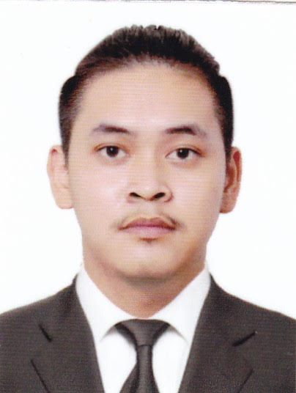
Lewis
Lewis.375322@2freemail.com

_________________________________________________

Objective: Obtain a position as a team-player in a people-oriented organization where I can maximize my customer-service experience in a challenging environment to achieve the corporate goals.

Professional Career:

Sales Associate
June-December 2016
Convergys Philippines

Job Description:
* Receive phone calls from customers who are experiencing issues with their phone, cable, and internet connection.
* Resolve connection issues over the phone or process a request for a technician dispatch if needed.
* Process customer requests for Self Installation Kits.
* Upsell on each call.
* Sell phone, cable, or internet bundles depending on the identified customer needs.
* Inform customers of the latest products and promotions.
* Meet all KPI targets set every month by the clients and the management.

Customer Service Representative
January 2017 - Present
Convergys Philippines

Job Description:
* Receive phone calls from customers who need assistance with their online account (Password Resets, Adding/ Changing Phone Numbers, Updating Email Address, Updating Personal and Banking Information)
* Answer customers' questions regarding sending and receiving money.
* Send follow up emails both to customers and other departments for follow up.

Achievements and Recognition:
100% Voice of the Customer Satisfaction Rating
Transfer Champion

Educational background:

Tertiary
Bulacan State University
2012 - 2016
B. S Bachelor of Sport Science

TECHNICAL/PERSONAL HIGHLIGHT
- Proficient in Microsoft Office,
- Proficient in Photoshop, and Video-editing software (Sony Vegas & Adobe Premiere)
- Able to comply to deadlines
- Able to perform in tight schedules
- Consistent and accurate in work field
- Ability to work under pressure on certain circumstances
- Good communication skills demonstrated by ability to work with people with diverse background
- Maintain a positive attitude while interacting with co-workers and in the field

PERSONAL DATA

Date of Birth: April 07, 1996
Civil Status: Single
Religion: Christian
Nationality: Filipino
Via Status: Visit Visa

CHARACTER REFERENCES:

References are available upon request

I hereby certify that the above information is true and correct to the best of my knowledge.

