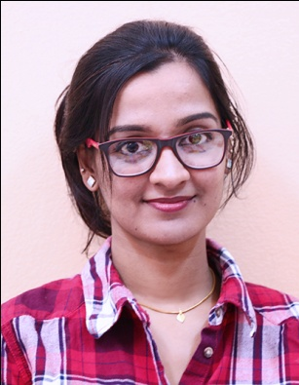
SRUTHI
Certified Professional Coder (AAPC)
Email: SRUTHI.375323@2freemail.com

Career Objective
Seeking a Medical Coder position in a clinic/hospital where I can utilize my medical apparel knowledge, administrative communication skills and find opportunities for growth and advancement.
Professional Certification
Certified Professional Coder (CPC) from AAPC (August 2017)
Summary
Strong ability to multitask and be a team player. Organized, disciplined and detail-oriented.
Strong knowledge of Anatomy & Physiology, Advanced Medical Terminology, and Pharmacology.
Sound knowledge in coding guidelines (ICD-10, CPT and HCPCS) and HIPAA Compliance.
Accurate assignment of procedural, diagnostic and evaluation and management codes for insurance billing and claim processing.
Reviewing claims data to ensure the required signatures and authorizations are in place, prior to submission.
Interacting with physicians and assistants to ensure accuracy and keeping track of patient data over multiple visits.
Maintaining patient confidentiality and information security.
WORK EXPERIENCE
Job Profile: Lab Coordinator (2014-2015)
Employer: Lifecare Hospital (A Unit of VPS Healthcare),
Mussafah, Abu Dhabi, UAE
Job Responsibilities:
Transcribing Lab Results.
Report Generation through SAP.
Coordinate patients for follow up lab test.
Coordinate supply ordering, delivery and storage.
Serve as the point person for patients, physicians and other hospital staffs regarding laboratory issues.
Take active role in envisioning new and improved quality of lab services.
Monitor, maintain and support the physical condition of lab space, computers, and all other office supplies.
Job Profile: Medical Coder (Part Time)
Employer: Revenue Plus Companies Management Abu Dhabi
A medical coding company focused on revenue cycle management, IT HMS solutions.
Job Responsibilities:
- Codification and insurance billing
- Resubmission
- Coordination and other client services and proper escalation of billing and coding errors
- Undergone training in preapprovals.

ACADEMICS
- M.Tech. Biotechnology - Lovely Professional University (CGPA: 6.3)
- MSc. Microbiology – Bharathidasan University (78%)
- BSc. Microbiology – Bharathidasan University (74%)

Other Certifications
- ‘Diploma in Medical Laboratory Techniques’ (DMLT) conducted by Department of Microbiology & Biochemistry, Dhanalekshmi Srinivasan College.

- ‘UGC Certification on Environmental Studies’ conducted by Bharathidasan University.

- ‘ISO 22000 based Advanced Food and Hygiene and Applications of HACCP based on Food Safety Management Sysytem (FSMS)’ conducted by FSSI.

Extracurricular Skills
- Languages
Fluent in written and spoken English, Hindi, Malayalam & Tamil.
- Computer Skills
Computer proficiency in operation of personal computers and software packages like Microsoft Office and Excel to create spreadsheets, graphs and statistically analyze data (i.e. averages, standard deviation, linear regression analysis). Proficiency in SAP and report generations using SAP.
- Supervisory Skills
Worked as part-time teaching assistant and evaluated a total of 180 undergraduate students over two semesters during M.Tech. Monitored activity of students and ensured safety provisions were used. Ordered lab supplies and maintained general business of the lab.

PERSONAL DETAILS

Date of Birth - 13/08/1987
Nationality - Indian
Marital Status - Married

References
Provided upon request.

Declaration
I hereby declare that all the above written particulars are true to the best of my knowledge and belief.
Yours Faithfully
Place :
Date :

