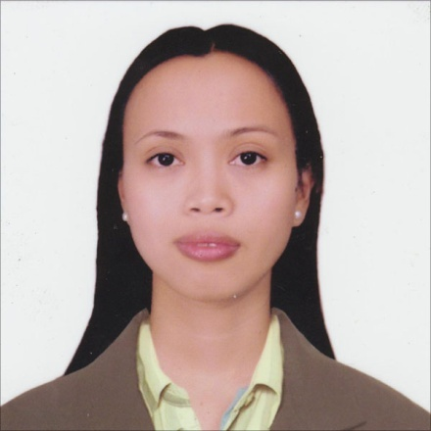

AIDA
AIDA.375340@2freemail.com

OBJECTIVE Currently pursuing career growth in a multinational company.

WORK EXPERIENCE

Apr 2010 – Dec 2016 STANDARD CHARTERED BANK, Philippines – SECURITIES SERVICES & TRUST DEPARTMENT (Associate)

- Handles documentations of retail, corporate, local, and global custody accounts – ensuring accuracy, completeness and timely submission; qualified to verify signatures
- Monitors accounts with document deficiency – mitigating potential risks;
- Safe keeps various documents (stock certificates, transfer certificate titles, trust agreement, etc) – performing periodic vault count
- Complies with audit requirements (internal and external auditors, local and regional)
- Performs client on boarding processes primarily related to account opening and Client Due diligence.
- Ensure handover of physical documentation for archival purposes.
- Review and process new client account opening documentation, client account updates and directional portfolio account opening.
- Process changes to client static data.
- Process closure of accounts.

Projects Handled: migration of processes to Malaysia, issuances of bonds, system enhancements, and process improvements.

Sept 2009 – Dec 2009 PSBANK, Philippines - DATA ENCODER (Project based)

- Encode telephone directory of prospective clients for verification purposes.

Mar 2009 - Aug 2009 BANK OF THE PHILIPPINE ISLANDS, Philippines - GENERAL CLERK (Project based)

- Manual processing of Statement of Accounts and Thank you letters.

Feb 2007 – Dec 2008 EMCOR INC., Philippines – SALES AND INVENTORY CLERK

- Prepares month end Sales and Inventory Report.
- Handle customer’s complaints.
- Work with other staff and suggest to supervisor and manager to keep abreast on the trends.
- Replenish fast moving items and mark down slow moving items

EDUCATIONAL BACKGROUND

2000 – 2004 SAINT MICHAEL’S COLLEGE (Magosilom, Cantilan, Surigao del
Sur, Philippines), Bachelor of Science in Computer Science
Extra-curricular: Vice President of Computer Science Department

1996 – 2000 SAINT MICHAEL’S COLLEGE (Magosilom, Cantilan, Surigao del
Sur, Philippines), Secondary

TRAININGS/ SEMINARS ATTENDED

Jul 2011 FRAUD: CLASSIFICATION, DETECTION, PREVENTION &
INTRODUCTION TO INVESTIGATING & PROSECUTING FRAUD
- SECURITY BANK MAKATI HEAD OFFICE , PHILIPPINES
Two days of training regarding fraudulent incidences in financial institutions

Sep 2010 SIGNATURE ANALYSIS & FORGERY DETECTION – BERJAYA
MANILA HOTEL, MAKATI CITY, PHILIPPINES
Became qualified to verify signatures

PERSONAL BACKGROUND

Born on May 3, 1983 in Surigao del Sur, Philippines. Fluent in English, Filipino, and Bisaya. Proficient with MS Word, MS Excel, and MS PowerPoint. Interests: reading, arts and crafts, and travelling to beautiful places. Excellent in Multi-tasking, Versatile, Attentive to details, and Team Player.

CHARACTER REFERENCES

Available upon request

