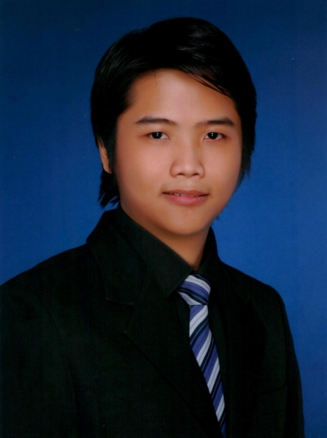
BIEN
BIEN.375341@2freemail.com

Personal Information
Religion: Christian Age: 28 years old
Status: Single Birth date: September 6, 1989
Degree: Bachelor of Science in Architecture
U.A.E. Experience 3yrs. (Dec, 2015 – Dec 2018)

Objectives
• Committing to deadlines is in top priority
• To perform actual work based on my acquired knowledge
• To explore latest technology with regards to Architecture principles
• To work harmoniously with other colleagues
• Team work and continuously learning
• Questioning is a learning procedure for me and for the company

Architectural Skills

• AutoCAD
• Sketchup
• Revit Architecture
• Space Planning
• Has the ability to do Scaled Models
• Drawing area computation requirements such as, GFA, FAR, BUA
• Drawing Coordination with MEP and Structural
• Knowledge in Detail Drawing

Qualification Summary

• Knowledgeable in Computer related programs (i.e. MS Office, )
• Punctual and good at time management
• Can work efficiently on a group or as an individual
• Has good communication skills
• Organized, hardworking, and a fast-learner
• Learning things is the key to success, even if it’s out of scope job.

Work Experience (Philippines)

- O.B. Mapua and Partners – Engineering & Management
(October 3, 2011 – June 29, 2012)
Unit 1705 Summit One Tower, 530 Shaw Blvd., Mandaluyong City, Philippines
Tel. No. 718-0078 / 535-8041

Cad Operator & Site Assistant

• Handled on-site projects like Apartment Hotels (Under The Stars Building) and Resort Hotels
(Villa Camila) at Boracay, Aklan.
• Had the duty to inspect the work of foremen and its accomplishments.
• Worked hand in hand with Architects and Engineers in the office and on the sites.
• Encoding Architectural plans, Structural details and Interior modeling.

- MODERNPHIL CORPORATION
(October 6, 2012 - December 31, 2012)
Warehouse 11, Armal Compund C. Raymundo Ave., Maybunga, Pasig City, Philippines
Tel. No. 640-5520 / 640-4148

Project in Charge at Site (PIC)

• Handled on-site project at UP Diliman "NSTP Building M"
• Building material management
• Had the duty to inspect the work of foremen and its accomplishments.
• Worked hand in hand with Architects and Engineers on site.
• Encoding Architectural plans

- Adrian T. Chua and Associates
(March 1, 2013 – October 15, 2014)
#56 P. Florentino Street Quezon City, Philippines
Tel. No. 7123439

AutoCAD Encoder/drafter
• Worked hand in hand with Architects that with architectural details
• Had the duty to inspect the project work files
• Had the duty to coordinate with the M.E.P.S. consultants
• Encoding Architectural plans (Condo, Residential, BPO, office buildings, and mix used
buildings
• 3D Modeling and conceptualization designs
• Worked hand in hand with Architects that with architectural details

Work Experience (3yrs Experience in DUBAI)

- CENYAR ENGINEERING / VE EXPERTS
From: Dec. 2014 - Nov 2017
Office 1, 1st floor, Karama, Zabeel Road, Dubai. P.O Box 122751
Tel: 043708909

- Working hand in hand with my senior Architect
- Drawing Coordinator
- Design Consultant
- MEP drawing coordinator
- Structural drawing coordinator
- Gen. Contractor Coordinator
- Submit Dubai Municipality Drawing

Projects:

Residential Villas
- Owner: Mr. Saleh Abdul Ghaffar Al Hashimi (Villa)
- B+G+1+Roof Private Villa
- Location: Jumeira First
- Plot no. 332 – 4582

- Owner: Mr. Mohd Rashad Al Hshimi (Villa)
- B+G+1 Private Villa
- Location: Jumeira First
- Plot no. 332 – 895

- Owner: Mr. Saeed Mubarak Obaid Murad Juma (Villa)
- G+1+ Villa + SB
- Location: Al Khawaneej 2nd
- Plot no. 282 - 8397

- Owner: Mr. Juma Saeed Matar Bin Lahej (Villa)
- G+1+ Villa + SB
- Location: Nad Al Shiba 4th
- Plot no. 617 – 4061

- Owner: Mohd. Ahmad Mohd. Matar Lahej Al Felasi (Villa)
- Ground Floor
- Location: Nad Al Shiba Fourth
- Plot no. 617-4128

- Owner: Ahmad Abdulrahim Ahmad Almalik (Villa)
- G+1 (4 Unit Investment Villa)
- Location: Alwuheida
- Plot no. 132-355

- Owner: Mr. Ali Juma Abbas Abdulla Al Blooshi (Villa)
- G+1 Private Villa
- Location: Nadd Al Hamar
- Plot no. 416-1412

- Owner: Mr. Mohd. Mubarak Obaid Murad Juma (Villa)
- G+1+ Villa + SB
- Location: Al Khawaneej 2nd
- Plot no. 282 – 8398

- Owner: Mr. Abdulrahman Ahmad Abdulrahman Ahmad Almalik (Villa)
- G+1+ Private Villa
- Location: Al Khawaneej 2nd
- Plot no. 282 – 7854

- Owner: Mr. Badreya Abdulrahim Mohammed (Villa)
- B+G+1 Private Villa
- Location: Al Barsha 2nd
- Plot no. 376-0583

Residential Building

- Owner: Mr. Jamal Saeed Juma Bin Ghalita Almeri (Villa)
- 4B + G + 5 + Roof Residential Building
- Location: Al Warqua’a First
- Plot no. 421-0304

- Owner: Mr. Faisal Aqeel Mohd. Noor Zainal Albastaki (Villa)
- G + 2 Roof Gym Residential Building
- Location: Al Badaa
- Plot no. 333 – 618

- Owner: Mr. Faisal Aqeel Mohd. Noor Zainal Albastaki (Villa)
- G + 2 Roof Gym Residential Building
- Location: Al Badaa
- Plot no. 333 – 618

- Owner: Mr. Mohammad Juma Bin Shabib (Villa)
- G + 2 Residential Building
- Location: Hor Al Anz
- Plot no. 127 - 0491

High-rise Building

- Owner: Mecury Invesment Holding Limited
- 5b + G + 29 + RF Residential Building
- Location: Business Bay
- Plot no. 346-0501

Education

University Degree
Bachelor of Science in Architecture ( 2006-2011 )
University of Santo Tomas
España, Manila, Philippines
High School and Elementary (1996 – 2006 )
Sacred Heart Academy of Novaliches
1155 Quirino Highway, Novaliches, Quezon City, Philippines

Vocational Course: (AutoCadd & Revit Architecture)

Microcadd Institute Inc.
SM North EDSA, Quezon City, Philippines

Omnix international,
Al Nasr Bldg No. 2
Oud Metha Road, PO Box 50999
Dubai, United Arab Emirates

Affiliations

•Microcadd Course AutoCadd
•Microcadd Course Revit Architecture
•Member of United Architect of the Phils. Student Affairs (2006-2007) ( UAPSA )
•Member of Red Cross Youth (2004-2005)

Seminars and Conference

•SMX Convention Centers for New Materials
•World Expo Convention Center
•CARSEM: Career Seminar for Graduating Students

I hereby certify that the above stated information is true and correct to the best of my knowledge.

BIEN

