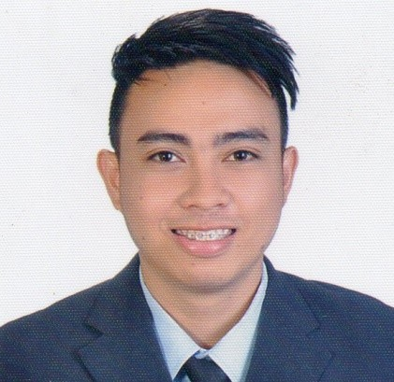

PROFILE

I am a graduate of Bachelor of Science in Industrial Engineering, a highly motivated and disciplined individual. I am willing to learn more with passion to succeed in my career. I have a positive outlook in life.

EDUCATIONAL BACKGROUND

TERTIARY:
Laguna College
San Pablo City, Laguna
Bachelor of Science in Industrial Engineering
2010- 2015

SECONDARY:
Liceo de San Pablo
San Pablo City Laguna
2005-2009

PRIMARY:
Dolores Central School
Dolores, Quezon
1999-2005
SKILLS
Facility Planning and Control, Method Studying, Time Studying, Quality Controlling, Production Scheduling, Computer Literate (MS Office), Sketch up Pro, Autodesk-Autocad2017, Good in oral and written communication

PERSONAL DATA

DATE OF BIRTH : March 07, 1993
PLACE OF BIRTH : San Pablo City
AGE : 22
HEIGHT : 5’’5
WEIGHT : 65 kg.
SEX : Male
NATIONALITY : Filipino
CIVIL STATUS : Single
RELIGION : Roman Catholic
LANGUAGE : Filipino, English
-----------------------------------------------------
I hereby certify that the above information is true and correct to the best of my knowledge and belief.

ROQUE, JHIN CLARISSE SUMIRAN
Sitio Santo Niño, Masin Sur Candelaria, Quezon
Contact # 09462087047
JHIN CLARISSE S. ROQUE

Mark
Mark.375343@2freemail.com

CAREER OBJECTIVE

Obtain a career in a reputed organization that allows me to grow professionally while being able to contribute my utmost capabilities and utilize the subject knowledge, communication, technical skills and experience gained in different areas of industrial engineering for the development of the organization.

SEMINARS/TRAININGS ATTENDED

Graduate - Prepare Computer-Aided Drawings leading to Technical
Drafting NC II (using AutoCad 2017) - 70 hours (PH 2017)

Participant- Introduction to Project Management (PH 2016)

Participant- Shaping up the Future Leaders (PH 2016)

Participant- 12th PIIE National Student Congress
Leadership Empowerment towards Nation Building (2015)

ORGANIZATIONAL AFFILIATION

PHILIPPINE INSTITUTE OF INDUSTRIAL ENGINEERS- PIIE
Member (2016-present)

Laguna College Engineering Department
Laguna College
President (SY 2014-2015)

ACHIEVEMENTS

Industrial Engineering Certification Board (IECB)
7th Certified Industrial Engineer Examination Passer
Certified Industrial Engineer (CIE) Reg. no 00521
2016- Present

Philippine Technological Council (PTC)
Associate Asean Engineer (AAE)
2016 - Present

JOB EXPERIENCE/TRAINING

Ponderosa Leather Goods Co. Inc.
002 Sumulong Hway Bo. Mayamot Antipolo City, Rizal, Philippines
Production Engineer (Nov 2015 – Nov 2017)

Farm Fresh Coco Oil Milling Corporation
Brgy. San Antonio 1, San Pablo City, Laguna, Philippines
Junior Industrial Engineer Intern (April-June 2014)

