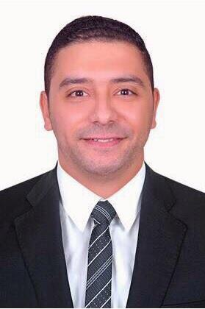
KARIM

E-Mail : KARIM.375350@2freemail.com

Date of Birth: 16-April-1991
Address : Dubai, U.A.E.

Visa status : Visit Visa

Intend to build a career with leading corporate of hi- tech scenario with committed & dedicated people, where my education, knowledge & experience can be fully utilized and realize my potential willing to work as a key player in challenging & creative environment in Construction Industry.

Education.

Bachelor of Civil Engineering 2015.
Mansoura University.

Certified by U.A.E. Embassy in Cairo.

Work Experience.

Civil Engineer (Site)
Al-Fanar For Constructions, Egypt, Cairo.

Celina Compound / Al-Louts Compound.
June 2016 until November 2017

- Follow up and technical supervision of multiple projects.
- Preparation of BOQ and maintenance works, Certifying and reviewing of the project disbursements

- Calculated cost and quantity estimates for public works projects.
- Attended project site selection studies.
- Preparing progress reports.

- Supervising the phases of construction and receipt of works, taking into consideration the engineering standards.

- Supervision during the casting process, sampling (cubes of concrete, slump test)
- Supervising the destructive testing of concrete and sampling (Core test) o Follow-up insulation work

Civil Engineer (Site)
ARCO
City Stars Sharm Al Sheikh.

June 2015 until May 2016

- Checking the steel reinforcements, cover blocks, lapping, Developments, Etc before handing over to Client for PMC's Checking

- Adopting the feasible concreting techniques and methods to avoid the honeycombs, segregation, bleeding of concrete, Cracks Etc. during and after concreting

- Preparing Concrete pour cards, PCC Pour cards, Check listing and Contractors Bills

- Liaising with the Project planning engineer regarding construction program
- Checking materials and work in progress for compliance within specified requirements
- Responsible for the completion of activities as per the scheduled durations

- Checking and preparing site reports, designs and drawings
- Preparing Bar bending schedule, Estimations of building
- Overcoming and solving of problems facing during the execution of activities
- Observance of safety requirements

Languages.

Arabic: Mother Tongue.
English: Good

Courses.

- AutoCAD
- ETABS

- SAFE
- MS Office

Additional skills

- Successfully coordinates programs and complete projects that achieve objectives.
- Effectively working to deadlines, independently and with cross-functional teams.
- Exceptional skill in functioning well in a high-pressure work environment.

- Knowledgeable in Civil Engineering and construction projects with follow occupational safety standards.

- Strong communicator with operational skills and a demonstrated ability to work well with people at all levels of an organization.

- Focused on increasing efficiencies and cost savings while maintain high quality.
- Always willing and able to learn new skills quickly.

- Strategic planner able to move visions into reality.
- Able to lead technical team, and provide project strategy and advices to them.
- Follow security rules and safety during the course of construction works.
- Make initial technical studies for new projects and preparation of reports and statistics related and collecting all information's.

- Knowledge of contract technical specification.

With Regards.

