Jeybin  Jeybin.375355@2freemail.com  PHP Web Developer | 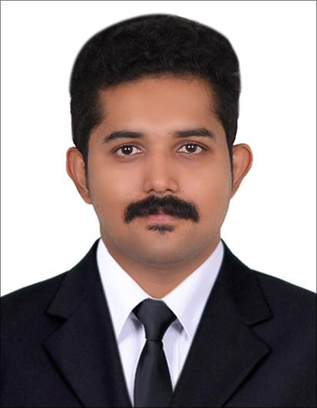
Dynamic Engineer equipped with 3 years and 8 months of outstanding work experience in developing competent software designs towards achieving best business functionality. Technically astute with sound knowledge in various development software, object or component oriented applications, database management system, web platforms and UI development activities. Possesses excellent analytical, problem solving, coordination and communication skills. Seeking an executive work profile in any progressive enterprise to share gained experience and developed expertise.

- Well-trained & Experienced Professional Competency in IT Project Handling Technical Team Leadership Ability
- Admirable Technical Support & Service Delivery
- Systems Installation, Configuration & Upgrading
- Security Solutions
- Database Design & Management
- Mobile application design and development
- Expertise in Software Engineering Strategic Planning & Solutions Implementation
- Abreast with the Latest Technologies
- Strategist, Creative, Innovative, Result-driven
- Commitment to Service Excellence

Qualifications
Diploma in Computer Engineering
K Karunakaran Model Polytechnic College, Mala, Thrissur, Kerala

Higher Secondary Education
Holy Grace Academy, Mala, Thrissur.

High School Education
Holy Child English Medium Higher Secondary School, Snehagiri, Mala, Thrissur.

Technical Proficiency
Languages | : PHP (CORE/OOPS), HTML ,CSS , JavaScript, C, C++, JAVA
Frameworks | : Bootstrap, Semantic UI, WordPress, Codeigniter, Laravel, Lumen, Slim, SASS/SCSS, Gulp, JADE, Blade, Jekyll, Twig, Angular, JQuery, Media Query, Chrome Extension Development.
Database | : MySQL, MySQLi
Academic projects
Main Project | : College Management in PHP
Mini Project | : Attendance Management System in Java  .

Achievements
- Completed Android Development Training in Spectrum Softtech Solutions pvt.ltd.
- Completed Php Web development training and project from phoenix operands, Koratty , kinfrapark.

Areas of Expertise

Backend Development
- Core PHP
- PHP OOP
- Lumen
- Codeigniter
- Slim
- Laravel
- AJAX

Frontend Development
- HTML
- CSS
- Bootstrap
- AngularJS
- AJAX
- JQUERY
- Javascript
- Media Queries
- Bootstrap
- Semantic UI

Template Development
- SASS/SCSS
- JADE
- BLADE
- JEKYLL
- TWIG

Build Tools
- GULP
- Webpack

Servers
- MySQL
- MySQLi

Others
- Chrome Extension Development

Version Controlling
- GitHub
- BitBucket

Software Engineering
- Develop, create, and modify general web development programs.
- Modify existing codes to correct errors or to improve its performance.
- Develop and direct software system testing and validation procedures, programming, and documentation.
- Confer with systems analysts, engineers, programmers and others to design system and to obtain information on project limitations and capabilities, performance requirements and interfaces.
- Analyse user needs and software requirements to determine feasibility of design within time and cost constraints. Design software or customize software with the aim of optimizing operational efficiency.
- Store, retrieve, and manipulate data for analysis of system capabilities and requirements.
- Consult with customers about software system design and maintenance.
- Coordinate software installation and monitor equipment functioning to ensure specifications are met.
- Obtain and evaluate information on factors such as reporting formats required, costs, and security needs to determine hardware configuration.

Project Management
- Help solve all the employee disputes that arise in the office.
- Maintain appropriate relationship with customers making certain that project results are comprehensible to management or steering committee.
- Document project progress like project file.

- My Works
- Words Worth Holidays
- Holiday Special Tours and Travels
- Riyas Babu Portfolio
- INDO-NORWEGIAN Cultural Society
- Kalyan Wedding Matrimony
- BeSpark
- Nss Madathumpady
- Namamkulangara
- Fab Tools UAE
- Demac Steels
- Rasoee Events
- Muringoor Church
- Monsoon Poetry
- Sindhu Kv Portfolio
- Ampac Precession
- Next Level Revolution
- Marriage World Matrimony
- Wack Industries
- ojus
- joscoae
- Sri C. Achutha Menon Government College, Kuttanellur
- Roxol Lubricants
- Simplex Builders
- K Karunakaran Memorial Model Polytechnic college
- Ranipradeepkumar.com
- Rapid Clean Oman

- Academic Projects
- Exam Seat Arrangement
- Fallo
- Lms 1
- Lessor
- Sot
- Three Wheels
- Uskool
- Captcha
- Career Management
- Catch My Seat
- College
- Cura
- Farming
- Film Booking
- Fresh Oven
- Job Portal
- LMS 2
- Real Estate
- Blood Bank

- Other Works
- Trade Watcher - Google Chrome Extension

Personal Details
Nationality | :  : | Indian
Date of Birth | : | 19th March 1992
Marital Status | : | Single
Languages | : | English

Declaration
I hereby declare that the above furnished details are true and correct to the best of my Knowledge

Place: Thrissur
Date: 01-12-2017

