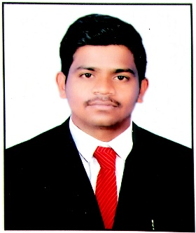
CURRICULUM VITAE

NARESH
Dubai, UAE
Mail Id : NARESH.375358@2freemail.com

Career Objective

To seek challenging assignment and responsibility, with an opportunity for growth and career Advancement as successful achievements.

Professional Summary
- 2 Years worked as a Sales Coordinator/ Marketing Representative in BED BATH KITCHEN & MORE Retail company Hyderabad, INDIA
- 6 months worked as a System Administrator
Qualifications

- Business Administration (MBA) from Jawaharlal Nehru Technological University HYD.
- BSC Computer Science from Govt degree College, Osmania University.
Experience
Company : BED BATH KITCHEN & MORE, Hyderabad, INDIA
Position : Sales Representative & Sales Coordinator
Duration : November 2015 to October 2017.

Duties and Responsibilities:
- Develop a knowledge of company products sales systems and procedures including proper merchandising
- Understand the customer needs and requirements
- Sales campaigns and promotions product sources and distribution, space management, programs, order guides and sales presentations
- Develop business relationships with store management
- Report to the management weekly and monthly
- Resolves customer complaints by investigating problems; developing solutions; preparing reports; making recommendations to management.
- Coordinate sales team by managing schedules, filing important documents and communicating relevant information
- Respond to complaints from customers and give after-sales support when requested
- Store and sort financial and non-financial data in electronic form and present reports
- Handle the processing of all orders with accuracy and timeliness
- Inform clients of unforeseen delays or problems
- Monitor the team’s progress, identify shortcomings and propose improvements
- Assist in the preparation and organizing of promotional material or events
- Ensure adherence to laws and policies

MBA Project

- Project work on “SALES & DISTRIBUTION” at TATA MOTORS
Technical Qualifications
- ERP : SAP(SD)
- Word Processor & Presentations : MS Word, MS PowerPoint, MS Excel
Functional Skills
- Enthusiastic, Positive Attitude
- Quick to learn and with good organizational skills.
- Has the ability to follow instruction and have a high sense of responsibility.
Personal Details

Date of Birth : 07-02-1992
Gender : Male
Languages Known : English, Telugu, and Hindi
Nationality : Indian
Marital Status : Single
Visa Status : Tourist
Visa Expire : 15 January 2018

DECLARATION

I hereby declare that the information furnished above is true to the best of my knowledge and belief.

Date :
Place : DUBAI

