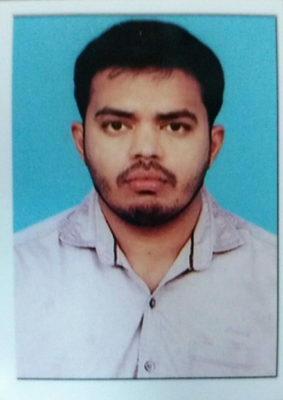
NAME : SYED
Email-ID :SYED.375364@2freemail.com
FIELD EXPERINCE : 4YEARS
WORK EXPERINCE
GULF EXPERIENCE
Organization : Hamed saud al-otaiby contracting Est
Duration : 2year (March2015 to April 2017)
Location :sadui arabia
Designation : Electrical supervisor
Description :Electrical panl borad switchgear,generator telephone maintance and RMU
INDIA EXPERIENCE
Organization : Magnetics AVALON TECHNOLOGIES PRIVATE Ltd.
Duration : 1Years (SEP2012 T0 SEP 2013)
Location :CHENNAI
Designation : PRODUCTION SUPERVISOR
Description : Vaccumimpergation machine operater,
step up &step down transformer,coil, soldering,
and transformer testing
Organization : Rohini industrial electricals Ltd.
Duration : 1Years
Location : GUJARAT
Designation : Electrical forman
Description : Electrical work
Highights of qualification:

- Hung experience working with heavy industry machinery and equiqment
- In-death knowledge of medium voltage distribution and low voltage
- Familiarity with NEC electrical codes and preditctive technologies
- Proficient in MS office suite
- Soild project management and communication skills
- Strong organizational and planning skills
- Excellent trouble shooting skills
- Skilled using electrical schematics and test instruments
- Outstanding ability to read and update electrical schematics using AUTO CAD
- I know that construction all electrical work
- Maintenance all electrical equiqment

Experience of knowledge
- I know that construction all electrical work
- Maintenance all electrical equiqment
- Understand the all electrical digram
- Hydrolical gate maintenance
- 3phase &single phase conection

Academic Qualifications
- D.E.E.E ., ARULMIGU SENTHIL ANDAVAR POLYTECHNIC COLLEGE,
TENKASI – Tamil nadu (India).(2009-2012)
- Higher Secondary School –R.P Hr,Sec School –ILANJI – Tamil nadu (India).2009

High school –R.P High School –ILANJI,
Tamil nadu (India).2007

Computer Knowledge
- MS Office
- Tally
- PCB desing
- Auto cad
- Electrical cad
- MEP revit

Declaration
I hereby declare that the above mentioned are true to the best of my knowledge and belief.

Date: Yours faithfully,

