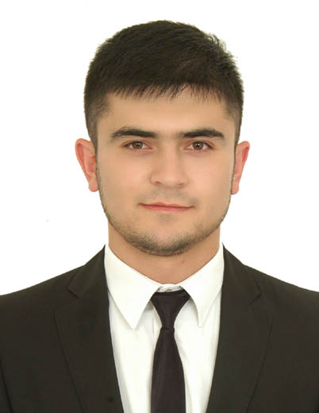
Personal Details

name : Okiljon
Date of birth : 18.09.1993
Nationality : Uzbekistan
Gender : Male
Marital Status : Single
E-mail : Okiljon.375377@2freemail.com
Visa Status : Employement visa
Address : Deira , Dubai , UAE
Height : 180 cm

Personal Profile

Strong team player, skills developed through work in customer service, a creative and motivated person with the will to succeed , well developed communication and team work skills , also the ability to work efficiently as an individual.

Experience:

Giordano Fashions LLC. ( UAE. Dubai. Sales executive 2017.02- present:)

RESPONSIBILTY.

Follow up on all 01 Cat.
Steaming and folding.
Ensure all documents are filled.
Stationary request and cleaning items.
WWS Updating when another staff is off.
Follow up with customer purchased reservations.
To work as a team in selling and store operations.
Good communication with customers, visitors and colleagues.
Responsible to achieve individual target a maintain a minimum of 95% in customer service.

Levi’s sport Fashion ( UAE. Dubai. Sales assistant 01.2015-01.2017 )

RESPONSIBILTY.

Providing extraordinary and luxurious experience to the very and each customers.
To monitor individual sales and achieve performance target and KPI given by Department Manager.
To work as a team in selling and store operations.
To create customer’s dream and desire to the brand, make them dream about the brand.
Greet the customer with the best and nice way and show them professional assist.
Honest in communication.
Take the initiative all the time when needed.
Represent the brand in a professional.

Zilli boutique ( Tashkent, Uzbekistan sales executive 2012-2014)

RESPONSIBILTY.

Creating unique luxury experience tailored to meet and exceed each customer expectation.
Creates and develops a positive relationship with the customers, from the first contact to the farewell.
Creates and cultivates a network of contacts to expand potential customer data base.
Gathers information about the market: new trends, events, competitors activities and products.
Maintain daily stock checking procedure, report to the Store manager and complete stock orders on time.
To welcome and greet customers to the store.
To treat everyone with respect and in a friendly manner.
Self motivates and focused towards career growth.
Represent the brand in a professional manner.

EDUCATION BACKGROUND:

Namangan city Academic Lyceum (Economy) 2009-2012

Skills:
Software
Microsoft (word, excel, office,) Adobe Photoshop, Internet,Social
Efficient, fast learner and flexible with the ability to finish task on time, can work under pressure.
Problem solving - thinking things through in a logical way.

Languages:

 | Listening | Reading | Writing | Speaking
English | Fluent | Fluent | Fluent | Fluent
Russian | Fluent | Fluent | Fluent | Fluent
Turkish | Fluent | Fluent | Fluent | Fluent
Uzbek | Native | Native | Native | Native
Farsi | Native | Native | Native | Native

Others
Interests

Swimming , Soccer, Fashion, Karate , Shopping, Bodybuilding,

