Abdel
Email: abdel.375397@2freemail.com
Employment Visa

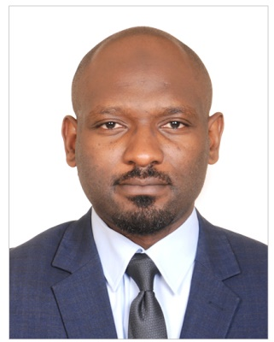

CAREEROBJECTIVE:

To reach a position which offers me key participation, team oriented tasks, immediate challenges, and career opportunity.

PROFESSIONAL WORK EXPERIENCE:

Organization: Infonet Institute
Tenure: June 2014-Till now
Designation: Business development Executive. Language Trainer: Arabic / French / English
Infonet Institute, a leading Educational and Training Organization in Dubai, UAE is a Management & Soft Skills Training Centre Established in the Year 1999. The Institute has a thrust on Professional Short Term Management Courses aimed at working Professionals.
Responsibities:
- Teaching Arabic and English language to beginners and intermediate
- Teaching French language to Beginners, Intermediate and advanced students.
- Corporate training Arabic language
- Business development
- Telesales

Organization: Gateway Insurance Broker
Tenure: March 2013-May 2014
Designation: Business Development Executive
Responsibilities:
- Elaborating and implementing marketing strategies for business.
- Managing a team for the attainment of business objectives.
- Cold calling, meeting customers to gather information about their insurance needs and tailor policies accordingly.
- Maintaining and developing relationships with existing customers.
- Reviewing own sales performance, aiming to meet or exceed targets.

Organization: EcobankBafusam Cameroon
Tenure: Jan 2010– Feb 2013
Designations: Sales Coordinator
The dual objective of Ecobank Transnational Incorporated (ETI) is to build a world-class pan-African bank and to contribute to the economic and financial integration and development of the African continent.

Responsibilities:
- Attracts potential customers by answering product and service questions.
- Plan advertisement, event organization and distribution of banking products
- Cold calling, phone calling and meeting customers individual and corporate
- Open customers saving or current accounts
- Maintains customer records by updating account information.
- Maintaining relationship with customers by follow-ups and promotional offers
- Cross sell other products of the bank specially credit cards and money transfer
- Contributes to team effort by accomplishing related results as needed

Organization: Afredit( Editor )
Tenure: Apr2010– Dec2012
Designations: Sales coordinator
Responsibilities:
- Survey of schools in determined locality and distribution of sample books for experimental applications
- Calling for assessment of the results of the application of sample books (Maths and French primary school books)
- Distribution of general knowledge books to customers of diverse sectors of activities
- Training the school teachers on the pedagogical use of proposed academic sample materials
- Meeting customers for the follow-ups and update of the information related to their needs
- Organizing promotional events to pull customers towards the products and enhance sales.
- Keep recording of the activities and reports for reference. Cold calling to arrange meetings with potential customers to prospect for new business.
- Responding to incoming email and phone inquiries.
- Negotiating the terms of an agreement and closing sales.

ACADEMIC EDUCATION:
EXAMINING BODY: YEAR
- Arabic and Islamic Studies Religious Institute Kuwait 1996-2002
- Graduation HND in Commerce Tankou Institute Bafusam 2003-2005
- Graduation BSc Marketing Nanfah Institute Bafusam 2006-2007

COMMUNICATION AND INTERPERSONAL SKILLS:

- Outstanding command over verbal and non-verbal communicative & interpersonal skills.
- Strong organizational, managerial, problem-solving, interpersonal and negotiation skills.
- Confidently able to work independently or in a team to deal effectively with educators & employees.
- Flair to organize & prioritize tasks to meet deadlines.
- Ability to manage multiple projects with minimal supervision.
- Training in Entrepreneurship from the international Bureau of Labour.
- Computer literate ( Word, Excel, Powerpoint ), typing speed 40 WPM ( Words Per Minutes )
- Have a good level command over English French Spanish and Arabic languages.
- Certificate in logistics and supply chain management from the KHDA Dubai.

PERSONAL INFORMATION:
Date of Birth : 04/02/1981
Religion : Islam
Marital Status : Single
Visa : Employment
Other : Member of Emirati Red Crescent

