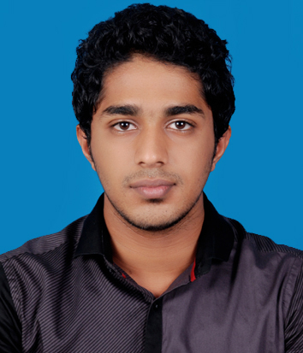
MUNEEB (CIVIL ENGINEERING)
MUNEEB.375404@2freemail.com

I am seeking for a competitive and challenging environment in a reputed organization where I can deliver my best and establish an enjoyable career for myself by upgrading my skills in engineering and meet the demands of the organization. Civil engineering graduate

ACADEMIC DETAILS

Qualification | Institute- University | Year | Score
B.Tech in  Civil Engineering | VIMALJYOTHI College of Engineering, Kannur KannurUniversity. | 2017 | 63%
Class XII | Marygiri English Medium School  Sreekandapuram,Kannur(Dt)  CBSE Board. | 2013 | 66%
Class X | Sal Sabeel Public School, Sreekandapuram.  CBSE Board. | 2011 | 8.8(CGPA)

ACADEMIC PROJECTS
Structural Analysis of Multistoried Building Using ETABS - Major Project (B.Tech).
Duration: 6 months Team Size: five Role: Project Member
- The main aim of the project is to analyze building using ETABS software and detail the structure. Autocad is used to prepare the plan.
- There are many other software such as STAAdpro etc.

Industrial training program (B.Tech)
Duration: 5 days Team Size: six Role: Team member
- Did a 5 days industrial training program at LASER AND TURBO Kochi metro.

ACHIEVEMENTS

- Selected for Sahodaya school level chess competitions
- Secured prizes in school level drawing competitions.
- Was in the College Football and Badminton Team.
- Actively participated in various sports activities for interschool.

TECHNICAL SKILLS
Languages Known | : C, C++, Assembly Language, Basics of SQL, JAVA.
Operating System | : Windows, Android, Ubuntu, ios.
Software packages known | : Microsoft Office, AutoCAD, STAADpro, ETABS,  A very good knowledge in REVITSTRUCTURAL.

SOFT SKILLS & INTERESTS

- Leadership :
Coordinated Collage tour program.
School Scout team caption.
Active participant in the School Arts program.

- Interpersonal Relationship Skill : Effectively at build trust and good relation with people.
- Able to Listen : Being able to actively listen to others.
- Sports : I’m passionate in playing football, cricket, volleyball, badminton.
Talented in chess and solving Rubix cube.
- Traveling : I love traveling and trekking.
- Confident and Determined

PERSONAL DETAILS

Date of Birth | : 04th December 1993
Languages | : English(Read,Write and Speak), Malayalam(Read,Write and Speak),Hindi(Read and Write),  Arabic(Read and Write)

DECLARATION

I do hereby declare that the above information to the best of my knowledge.

Place: Dubai

