Adil
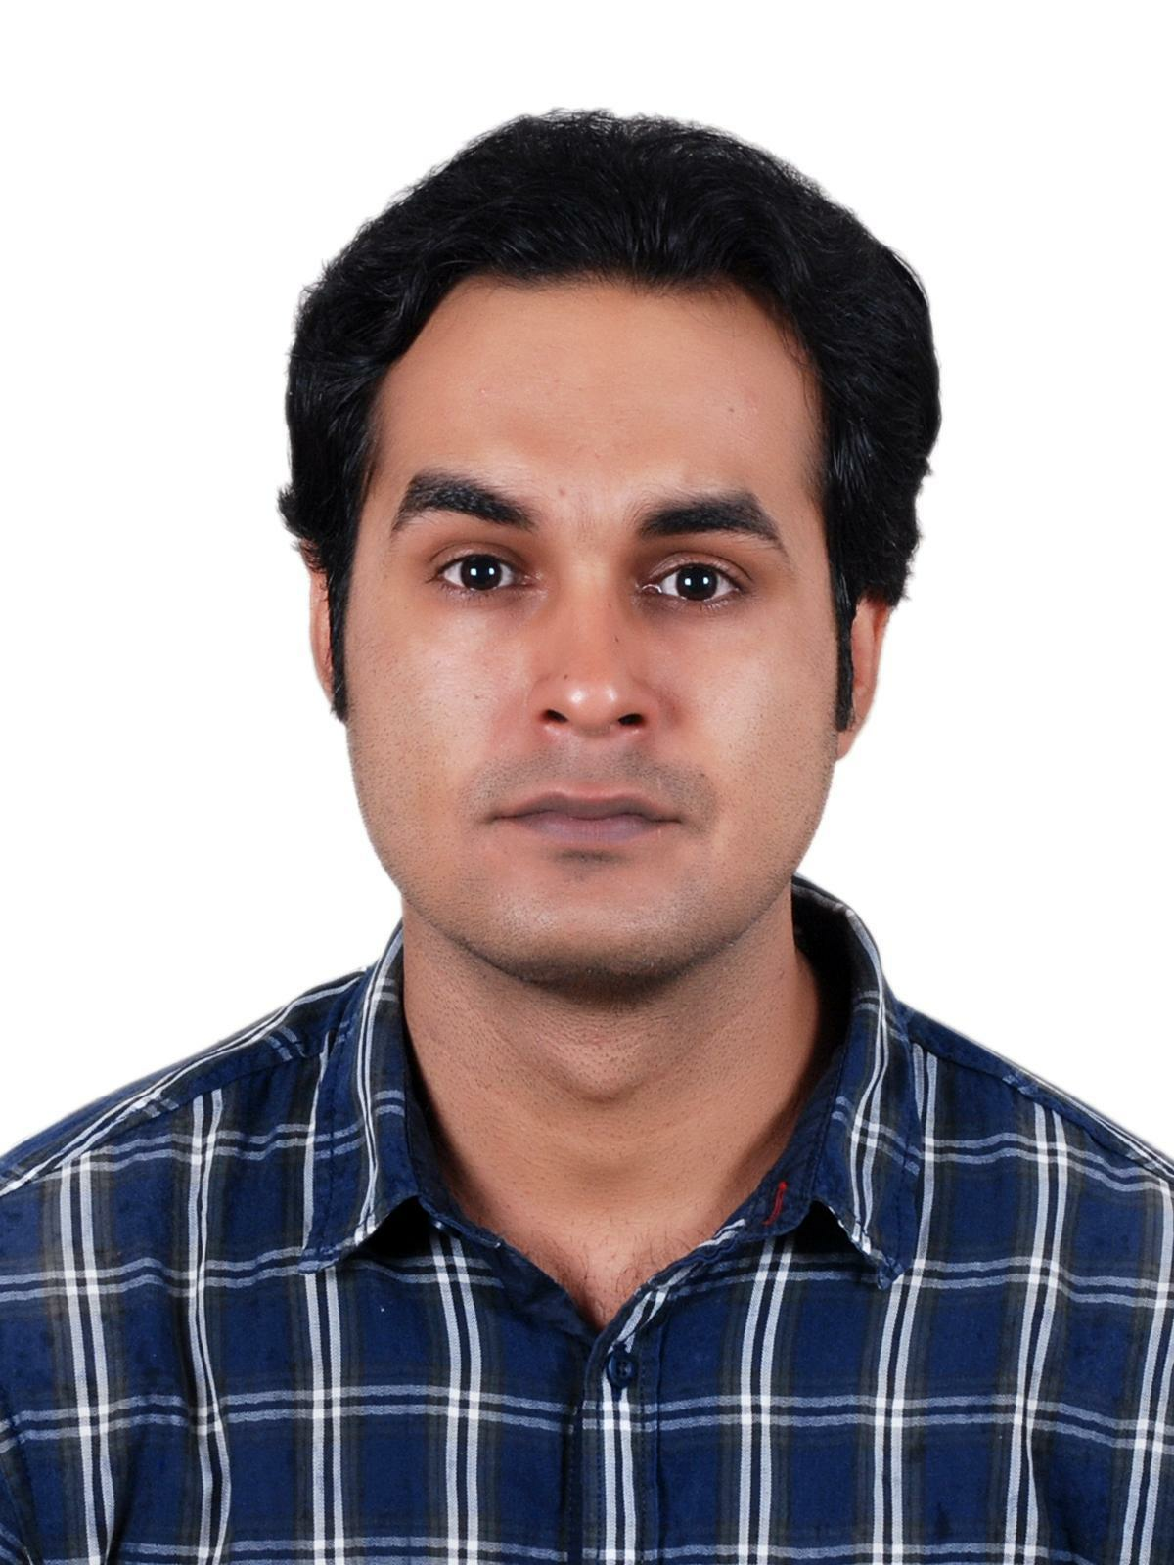
Email – Adil.375412@2freemail.com

A BRIEF OVERVIEW
- A dynamic professional with 4.5 years of experience in the Direct Sales And Insurance sector.
- Strong business acumen with skilled in interfacing with corporate clients / channel partners for suggesting the most viable products as well as cultivating relations with them for securing repeat business by mapping their requirements and providing them customized business solutions through new proposals, presentations and demonstrations.
- Experience in handling of Direct clients Services.
- Experience in handling marketing of insurance products.viz Motor, Health, Retail, Property and Engineering.
- Adroit in handling business development, identifying & developing new markets, lead generation, client retention and achieving targets.
- Possess credibility & personal integrity that leaves lasting impressions with decision makers, motivate channel partners and generate loyalty.
- An effective communicator with excellent analytical / logical skills and an ability to relate to any people at any level of the business and management.

With exceptional communication and interpersonal skills, I am with self - confidence, innovative approach and quick adaptability to achieve objectives of the organization.

MARKETING PROFESSIONAL
Seeking a position in the organization that provides me ample opportunity to explore & excel in the field of Sales and Marketing while carving out the niche for personal, professional as well as organizational goals.

PROFESSIONAL EXPERIENCE

GETIT INFOSERVICES PVT LTD. (September 2013 - April 2015)

Position : Marketing Executive - Area Team

Responsibilities

- Developing and appointing channel partners to expand product reach in the market and ensuring meeting of revenue targets
- Responsible for sales of products such as online marketing, SEO( Search engine optimization), Google Ads, Websites etc
- Developing and appointing channel partners to expand product reach in the market and ensuring meeting of revenue targets.
- Writing up sales reports, activity reports and revenue forecasts.
- Completing all documentation and administrative records, fully and accurately.
- Interacting with clients regularly to gain feedback on quality & service effectiveness.
- Managing staff levels to ensure that key target marketing areas are always covered.
- Advancing the company's strategic positioning with key accounts and strategically important geographies.
- Maintaining strong and cordial relationships with corporate level sales and marketing managers.
- Identifying and monitoring the performance of competitors in the market place.
- Providing excellent customer service to designated accounts.

Tata AIG General Insurance Company Limited (18th May 2015 - Till date)

Position : Key relationship manager - OEM Team
Profit center head, Team Management, Training and
development, Operation and compliance & maintaining
healthy NCR.

Responsibilities:

- Spearheading sales efforts across the region which includes planning & conceptualizing various strategies to achieve business goals of the company aimed towards the growth in business volumes as well as profitability.
- Analyzing the client/IMD requirements as well as facilitated the best quotes from the technical team.
- Submitted quotes as well as followed up with the clients / agents as per the required time till the finalization of the proposal being set
- Handling business from inception to services.
- Team Handling and ensuring budget achievement of team.
- Expertise in recognizing new markets to facilitate deeper market penetration and thereby increasing the market share of the organization.
- Developing a competitive business development and sales strategy, uncovering/ creating new opportunities and identifying dynamic and flexible solutions.
- Competently maintaining highest standards of customer service giving preference to customer satisfaction & promptly resolving customer problems & concerns.
- Leading efforts across reviewing & assessing the existing trends; preparing sales forecast for enlarging the core market base of the company.
- Prepare MIS reports for facilitating the decision making process (Ensure timely order execution and collection to ensure smooth operations.
- ATL and BTL activities

EDUCATIONAL CREDENTIALS

Bachelor of engineering, VTU university, Bangalore.

Extra Curricular Accolades
- Elected as Placement Co-ordinator of Engineering college
- Played for College Cricket Team at VTU UNIVERSITY Level.

NOTABLE HIGHLIGHTS
- Awarded with Certificate of Excellence for outstanding performance.(2014)
- Awarded with Exemplar certificate for outstanding performance. (2015 and 2016)
- Successfully designated with premium targets as well as achieved the same effectively.

IT SKILLS

Well Versed knowledge of MS-Excel and Powerpoint.

PERSONAL INFORMATION

Date of Birth: 24th January 1990

Hobbies: Listening to Music, Playing outdoors games.

Languages Known: English, Hindi.

