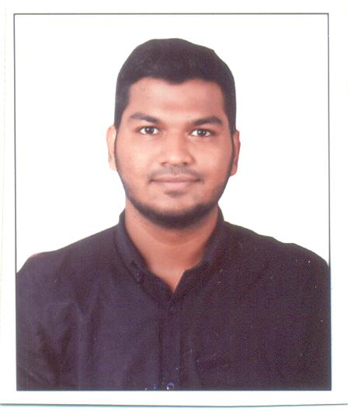
CURRICULUM VITAE

MAHAMMED
Email Id: MAHAMMED.375428@2freemail.com
Objective :
To utilize my skills and abilities to the best possible extent and to hold challenging position to set an example of high standards of performance as part of the team.

Educational Qualification
Qualification | Name of Institute | Year of Passing | Board or University | Percentage
SSLC | Adarsha Bharathi High School, Padil, Mangalore. | April 2012 | Karnataka Secondary Education Examination Board | 62.08%
PUC | Milagres PU College, Mangalore | March 2014 | Dept. Of Pre University Education | 67.33%
I.T.I Mechanical Fitter | Hebich Technical Training Institute, Mangalore | 2014 – 2106 | NCVT, Govt. of India. | 1ST Sem -65.28%  IInd Sem – 64.71%  III Sem – 70.77%  IV Sem – 72.30%

Additional Qualification : “CNC Programming and Operation” Course Completed
Basic Computer knowledge
Work Experience: One year experience at SB Globe industrial PVT.LTD.

Personal Details
Name : Mahammed
Date of Birth : 06.01.1997
Gender : Male
Marital Status : Single
Nationality : Indian
Linguistic Proficiency : English, Hindi, Kannada, Tulu and Malayalam.
Hobbies : Reading Books
Declaration :
I hereby declare that the above information true and correct to the best of my knowledge.

Date :
Place: Mangalore MAHAMMED

