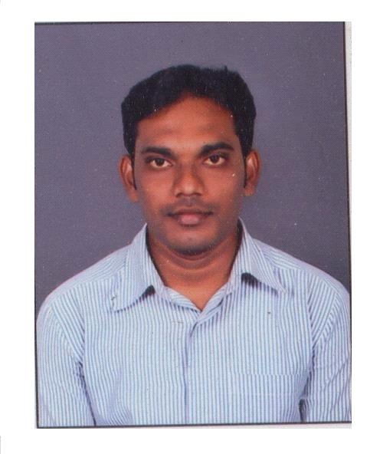  E-mail:  RAVI.375443@2freemail.com  Personal Information  *DOB : 10-06-1985  *Gender : Male  *Marital status : Single  *Nationality: Indian  *Languages  : English  : Telugu  : Hindi  VISA STATUS : Visiting  VISA VALIDITY : 18/02/ 2018  Key Skills  - Good relationship skills within the organization  - Group co-ordination.  - Commitment to work and willingness to learn more  - Ability to adapt to any working environment.  STRENGTH  - Passionate towards service  - Updated knowledge in the field of medicine  Passionate towards service  - Good communication skills  - Can follow the hospital rules  - Experience in handling in & out patient  PROFESSIONAL SKILL SET:  - Stroke patient rehabilitation  - Pre and postoperative physiotherapy after joint replacement  - Home care physiotherapy  - Bronchial hygiene, chest physiotherapy  - Seminars / Workshops skill set | CAREER OBJECTIVES.  To be professionally associated with an organization where one can demonstrate his workmanship and skill with a spirit of teamwork. Thereby achieving objectives of the organization and rewarding self with professional elevation.  EDUCATIONAL-QUALIFICATIONS  COURSES COMPLETED UNIVERSITY BORD YEAR  Medical coding AAPC, Medecode solutions AP,INDIA 2017  Bachelor of physiotherapy NTRUHS,AP,INDIA 2012  12th Vocational physiotherapy AP,INDIA 2005  10th SSC,AP,INDIA 2001  PROJECTS  Physiotherapy management for “Golfers Elbow”submitted to Dr.NTR University, Vijayawada, AP.  TECHNICAL-QUALIFICATIONS  - MEDICAL CODING CERTIFICATION COURSE- AAPC FROM MED-E-CODE SOLUTION HYDERABAD, INDIA  WORKSHOPS-CONFERENCES  Complete the american heart association BASIC LIFE SUPPORT PROGRAM at medline academy, hyderabad,telangana.INDIA  - Workshop on ON FIELD & THERAPEUTIC TAPING condected by eploris physio acodamy,new delhi. INDIA  - workshop on INTERNATIONAL TAPING COURSE BASICS & ADVANCED 2 DAYS conducted by physio foundation india & krishna institute of medical sciences college of physiotherapy at kims hospital, hyderabad,telangana, INDIA  CLINICAL WORK EXPERIENCE  - Working as a Clinical Physiotherapist from 01/09/2013 till 01/11/2017 OZONE MULTI SPECIALITY HOSPITAL, HYDERABAD, AP,INDIA.  PROFESSIONAL ASSOCIATIONS  - Member of Indian Association of Physiotherapists  (IAP Reg No: )  PROFESSIONAL EXPERIENCE  - Six month Physiotherapy training in all specialty departments at GUNTUR GENERAL HOSPITAL, GUNTUR,AP,INDIA during JULY/2012–JANUARY/2013.  - Six month Physiotherapy training in all specialty departments at SATYA HOSPITAL, GUNTUR,AP,INDIA during JULY/2012–JANUARY/2013.  - Six months physiotherapy training in all specialty departments at OZONE HOSPITAL,HYDERABAD,TELANGANA,INDIA during March 10th 2013 – August 31st 2013  DECLARATION  I do here by declare that the above-mentioned information is true & correct to the best of my knowledge & belief.  Date:

