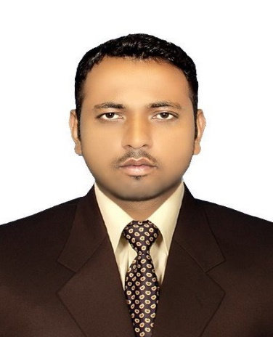
Uzair

☒ Email: uzair.375454@2freemail.com
Employment | BURAQ ENGINEERIG Mechanical and Electrical  MAY 2013-DEC 2017  Duties :  - Performs all types of repairing and did servicing of all types of modern cars including Petrol and diesel engines.  - Jobs includes general repairing and also preventive maintenance.  - It also includes Engine replacements, overhauling, and all other trouble shouting of engines.  - Experienced in Hybrid Cars including Toyota, Honda, Lexus, Rang Rover and all other moderate hybrid vehicles, did repairing and replacements of Hybrid batteries and motors.  - Got expertise in suspension overhauling and troubleshooting  - In workshop perform all types of electrical and mechanical works such as troubleshooting of brakes, ABS, EBD, Dash light, Steering and all other major works of cars.  - Understand and work on GSCAN 2, and Launch did diagnosing of electrical faults and can able to fix ever type of hybrid and other electric issues.  - All type of Key Programming and CVT Calibration.
As Vehicle  Technician  (Jun2010-To  April2013) | Vehicle Technician  Honda Centre (Pvt) Ltd, Rawalpindi , Pakistan  Jun 2010 – April 2013  Responsibilities:  - Perform all types of repair/service jobs of all Honda Vehicles in Periodic Maintenance and Quick Repair Department.  - AC gas refilling machine operator.  - Brake Lathe/disk turning on brake lathe (MAD Disk Aligner 2002 & 8700).  - To maintain the performance as a technician and works up to the entire satisfaction of the company and valued customers.  - To diagnose faults in vehicles by using HDS (Honda Diagnostic System)  - To train Internees and newcomers  - Engine Overhauling and replacement  - Automatic and manual transmission repairs and replacement  - Suspension Overall
Trainings  MT training: | 8 weeksMaintenance Technician training held at HACPL (Honda Atlas CarsPakistan Ltd) Lahore and got 1st positionin contest.
Technical  Skills | Hand on Experience on debugging and repairing of vehicles, sound knowledge of all SST (Special Service Tools), Pneumatic guns and power Tools.
HDS: | Hand on Experience  Honda Diagnostic System (HDSis a program use to check vehicle electrical & check light which is operated by computer by usingHIM(Honda interferencemodule)
Brake Lathe: MAD Disk AlignerDA-2002 and DA-8700 (Both machines are used for disc plate alignment without removing plate from vehicle )

Education Diploma of Associate Engineering (DAE) 3 years, Auto & Diesel Technology
2007-2010
International Islamic University, Islamabad

Matriculation
2005-2007
FBISE Islamabad

Personal Profile
ate of Birth 17-10-1988
Religion Islam
Nationality Pakistani

Co-curricular Was a player of Cricket team in Islamic University.
Activities Member of Hiking Club in Islamic University.

