KANIMOZHI

Email: kanimozhi.375479@2freemail.com

Looking for a position as a CUSTOMER SUPPORT EXECUTIVE in dynamic environment where experience and professionalism are valued and required as means of attaining company success in strategy.

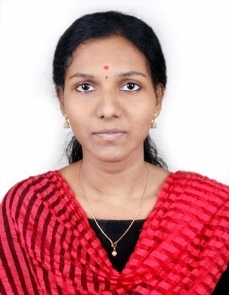

Areas of Proficiency

- Customer Calls Handling

Dealing with Walk in Clients

- Team Co-Ordination

Quality Analysis

- Solving Customer Queries Ensure Effective Sales

Professional Synopsis

- Senior Consultant at Sutherland Global Service for UBER Process in Chennai, India.
- Promoted as Resolution Expert to train the New Employees for Uber Process.
- Promoted as Quality Analysis for Cross check the Consultants Works for Uber Process.
- Professionally Qualified with Bachelor of Electronics and Communication Engineering.

- Proven ability to manage multiple assignments while meeting tight schedules.

- Having Practical knowledge in the accounting application MS Office.

CAREER TRAJECTORY

Senior Consultant– Sutherland Global Services (SEP 2015 – MAY 2017)

Client : Uber Process, Chennai.

Responsibilities Undertaken as a Resolution Expert:

- Αssist team members on their day to day process related queries.
- Find teams performance with weekly audits and guide towards their progressive improvements.
- Conducting one on one meeting on a weekly basis and providing real time feedback about their mistakes.
- Provide leadership with daily snapshots of team’s performance and escalate issues to senior leadership if necessary.

Responsibilities Undertaken as a Quality Analyst:

- Αct as a Quality analyst on identifying the DSAT(Customer Dissatisfaction) on Uber Process.
- Identifying Mistakes done from consultant on major issue type and Cascading the same to that particular team.
- Identifying the trending issues from process side and cascading the same as key call outs to the Uber Clients.
- Εnsure Process Flow and SOP(Standard Operational Procedure) is followed on various issue types by conducting Dip-Check with the teams.
- Attend Client Calibrations and escalate queries through telephone calls to Uber clients.

Responsibilities Undertaken as a Consultant:

- Giving Solution for Customer queries through emails.
- Calm/Angry customers, Repair trust, locate resource for problem resolution and design best option solutions.
- Deliver 5 star, in-person to the rider as well as to the driver partners.
- Stay focus on day to day work and maintaining the CSAT(Customer Satisfaction), FTR(First Touch Resolution) and TPH(Ticket Per Hour) properly.

PERSONAL TRAITS

- Self- adaptability based on the environment.

- Task oriented, analytical and able to produce accurate work results.

- Flexible with a positive “can do” attitude.
- Able to work under Pressure.

 |  |  | ACADEMICS
UG | Dr. S.J.S Paul Memorial College of Engineering and Technology, Pondicherry.
(2011-2015) | B.Tech (Electronics and Communication Engineering)- 7.92 CGPA

PERSONAL PROFILE

Date of Birth: 13-08-1993 Gender: Female

Visa Status: Visit Visa (Nov-17-2017 to Feb-15-2018) Nationality: Indian

Language Known: English, Tamil. Marital Status: Single

Declaration

I hereby declared that the above given particulars are true to the best of my knowledge and assure that I will put the best of myself.

Date: Signature

