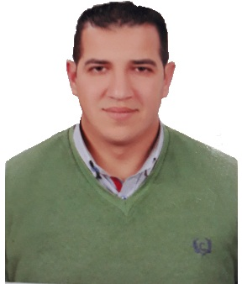
CURRICULUM VITAE

Elsayed
Email: elsayed.375488@2freemail.com
Place of Birth: ALEXANDARIA, Egypt
Military Status: finished
Marital status: Married
Objective
Seeking a Marine engineer position with a company which will require me to utilize my skills, abilities and experience in the marine field to ensure the company's success.
Summary of qualifications
- Over 8 years' experience in marine field (Shipbuilding, Ship repair, diving services and marine projects).
- Project manager of project (assembly two Boatlift 800 ton at Alexandria shipyard and Egyptian company for shipbuilding and repair).
- Inspector for marine fenders at Qingdao (China), Marine rubber fenders and Foam filled fenders.
- Project manager of building 50 M Cruise yacht At Hefni Shipyard in safaga.
- Project manager of repair cell 95 in jet 9 at Damietta port
Educational background
- B.SC in Engineering, Department of Naval Architecture and Marine Engineering, Alexandria University, May 2009.
- Graduation Project: Design of Offshore Supply Vessel (X BOW ANCHOR HANDLING TUG SUPPLY VESSEL).
- PROJECT SUPERVISOR: DR. HEBA WAEL LEHETA.
Studied courses
- Maritime safety and risk management
- Offshore structure, design and analysis
- Naval architecture
- Ship construction
- Ship design
- Ship propulsion system
- Marine power plant
- Refrigeration and air conditioning
- Feasibility study
- Ship economics
- Shipyard technology
- Ship hydrodynamics and maneuvering
- Design of Nile floating hotels
- Material technology
- Industrial safety
Languages
- Arabic: Native Language
- English: Excellent
- Italy : Good
- Chinese : Good
Software Skills
- Good knowledge of computer hardware and operating systems.
- Excellent with Microsoft Office Applications.
- Good Knowledge of Internet Applications and Search Engines.
- Excellent Knowledge of AutoCAD.
- Excellent knowledge of Engineering Equation Solver (EES).
- Excellent knowledge of Maxsurfe and Hydromax prog. (For ship designs&
- Stability).
- Excellent knowledge of EDI SACS prog. (For design of offshore structure).
- Excellent with Autoship program.
- SAP 2000.
- Good knowledge of maritime software.
Certificates
- FIRE FIGHTING CERTIFICATE FROM (ARAB ACADEMY OF SCIENCE
- AND NAVAL TRANSPORT)
- COROPORATE RESPONSABILITY CERTIFICATE FROM (ARAB
- ACADEMY OF SCIENCE AND NAVAL TRANSPORT)
- LIFE SAFETY TECH CERTIFICATE FROM (ARAB ACADEMY OF
- SCIENCE AND NAVAL TRANSPORT)
- FIRST AID CERTIFICATE (ARAB ACADEMY OF SCIENCE AND NAVAL
- TRANSPORT)
- NON-DESTRUCTIVE TESTING (NDT)
- MT - Magnetic Particle Testing
- VT - Visual Testing (VI - Visual Inspection)
- INTERNATIONAL SAFETY MANAGEMENT [ISM].
- INTERNATIONAL SAFETY MANAGEMENT AUDITOR [ISM
- AUDITOR].
- TURBO MACHINERY EQUIPEMENT [EGY CET SOCIETY].
- SALES & MARKETING SEMINAR [NEW HORIZON].
Work experience
International Maritime group (from 1-8-2015 till now) work as project manager.
Contact details:
12. Champollion St., AlAzarita-7th floor
APT.No.703-Alexandaria, Egypt
Phone: 002-03-4854498
Fax: 002-03-4854493
Email: info@arwadmarine.com
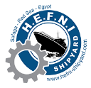
Hefni shipyard (from 1-2-2015 to 30-7-2015) Work as project manager for build INS 50 (Cruise yacht).
Contact Detail:
Safaga, Red Sea, Egypt
Phone: 00201066654508/22
Email: Info@hefni-shipyard.com
Web: www.hefni-shipyard.com
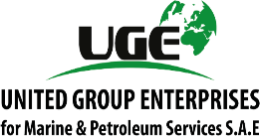
United Group Enterprise for Marine & Petroleum Services (from 1-1-2014 to 28-1-2015) Work As a project manager and diving engineer for various offshore, marine project, diving services, pipeline installation, offshore structures inspection and ship launching with air bags.
Contact details:
Tel: +2033814718
Fax: +2033814719
Email: info@unitedge.com
Web: www.unitedge.com
TECHNO MEC ENGINEERING & STEEL WORK MARINE & IND
All pipelines instillation 2. Dredging underwater 3-Maintenance works (of ship mechanical system)
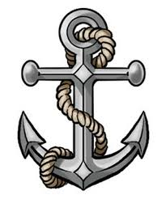
CLASSIC MARINE (Consultation and Design Office) /
Alexandria / Egypt, as a technical and project engineer and Designer for various offshore& marine project such as- jack-up barges, installation rock armor.

ARAB CANADIAN AGENCY FOR MARITIME AND PETROLEUM
SREVICE AS DESIGNER AND SITE ENGINEER
SAMPLE OF PAST PROJECTS
In Offshore field

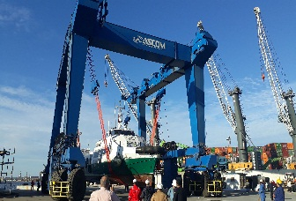
Project Manager of assembly two 800 Ton boatlift
International Maritime Group as Agent of ASCOM Supply and install two boatlift each is 800 to for Ministry of defense of Arab Republic of Egypt
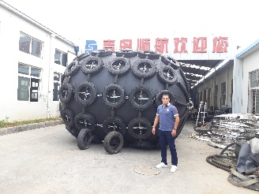
Project Manager of supply and install 13 Foam filled fenders and 10 pneumatic rubber fenders
Alexandria international terminals company ask IMG for supply and install 23 fenders ( Foam filled and pneumatic rubber fenders ) , so as technical engineer with experience in this field I travelled to china for test and supply this fenders.
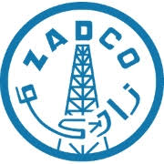
Cost Estimator of project Satah Al Razboot (SARB) Oil Field, located in the Arabian Gulf in the United Arab Emirates (UAE), approximately 120 km offshore North-West of Abu Dhabi City and about 20 km to the South-East of Zirku Island, which accommodates the facilities of another offshore oil company (ZADCO).

Project manager of project (Repair cell (94) at jetty (9) Damietta port :
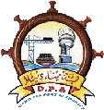
Cell Built from( straight web Sheet biles AS-500-12mm) ,We Treatment the damage in The cell with The same sheet biles (By welding straight web sheet around damage area Under water according the consultant design ) and treatment the crown beam above sheet biles by an metal bond and fill with steel concrete (all of this works underwater).
Cost Estimator of project Design and Renovation of Old Jetty Quay Wall at Doha Port.
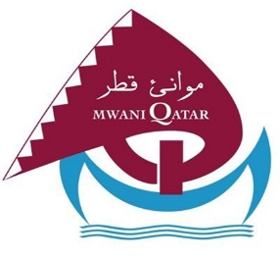
Qatar Ports Management Company is aiming to renovate the old wooden ships jetty quay wall. As United Group Enterprises have a great experience in diving services and underwater inspection, so we are honored to submit an offer to perform the required underwater services.

In ship design & ship building field
Project manager of built new pleasure boat (INS 50) With Bureau VERITAS Classification society with the Spain Design office Insenaval
- Built 100 ton Steel construction with 40 ton aluminum sheets
- Starting Pipelines with fittings.
Project manager of building Anchor HANDLING TUG SUPPLY VESSEL (SEAPREEZE) 32 M (LOA) MORE THAN 500 GROSS TONNAGEs for Sea Breeze Company.
- Design model
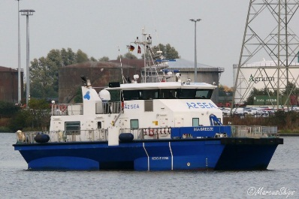
- All drawing for construction, Piping, Machinery. Electricity
- Supervision of building it at elhamed shipyard
- Execute all piping, machinery and electrical systems
- Intact and damage stability calculation and Sea trials
Naval artichture and supervisor of building crew supply vessel CANADA 1 (30
M crew supply vessel building under supervision of classification society
(RINA)).
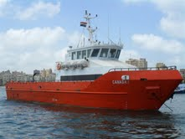
- Design model
- All drawing for construction, Piping, Machinery. Electricity
- Supervision of building it at elhamed shipyard
- Execute all piping, machinery and electrical systems
- Intact and damage stability calculation
- Sea trials
Supervisor of Pulling up, maintenance and launching of Nile floating hotel (Queen abo-simple (Al-Nabila)) (150 m in length 15.5 m breadth with light
- Weight of 4000 ton).
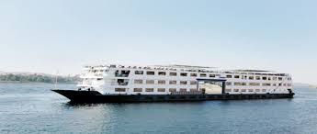
- Pulling up the Nile floating with air bags
- Change more than 50 ton of steel for hull and inner construction
- Replace the two main engine and emergency generator and some Mentainance for piping and electrical system
- Launching the floating hotel by air bags
SUPERVISOR OF BUILDING MOTOR YACHT (SCUBA SCENE) 43 M IN SUEZ (elmoadat yard and complete built at oceandro under supervision of classification society (RINA))
- Full design (Model and all drawing under supervision of ENG / Mohamed Gaber
- Supervise of building the yacht
References
- Available upon request

