KARTHIKEYAN  KARTHIKEYAN.375521@2freemail.com | 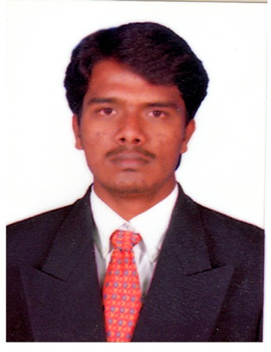

Objective
I am seeking an exciting and challenging position within a dynamic and innovative organization which offers variety and the opportunity for my career growth.

EDUCATIONAL QUALIFICATIONS
B.E – Electrical & Electronics Engineering from Mookambigai College of Engineering, Tamilnadu in India, secured 70% (First Class) , April 2012.

EXPERIENCE SUMMARY

Organization | : | Zahran Operations & Maintenance Co.,KSA.
Location | : | King Saud University Project, Saudi Arabia
Designation | : | Electrical Engineer
Duration | : | June 2015 to May 2017

Job Responsibility
- Supervision of Switch-gear operation system & sub-stations.
- Daily maintain the total plant power consumption report and Analysis of electrical consumption & consumed demand.
- Responsible for the electrical maintenance work procedures, Check lists, Daily , Weekly & Monthly progress reports.
- Updating and closing the Preventive maintenance & Breakdown maintenance work orders and reported to project manager at the right time.
- Conducting daily tool-box meeting and preparing Job safety analysis with crews before start any job.
- Good experience in maintenance of plant and equipment, such as heavy electro-mechanical rotating machines, pumps, compressor and blowers.
- Preparing Preventive maintenance schedule and maintaining equipment history, vibration, temperature record for Rotating equipment.
- Good knowledge of VFD.
- Checking of both power and hand tools for maintaining good condition.
- Carrying out daily electrical safety inspection to identify unsafe working condition and unsafe practices.
- Attend the weekly safety committee meetings.
- Shift Handing individually.

Organization | : | Memiontec (Pte) Ltd., Singapore.  (Specialists in water & waste water treatment)
Designation | : | Plant Supervisor (Kranji Ne-water Plant)
Duration | : | April 2014 to March 2015

Job Responsibility
- Responsible for the total plant electrical maintenance work procedures, Check lists, Daily , Weekly & Monthly progress reports and systematic approach with PTW and maintain operation records such as PM & BM properly.
- Experience in water treatment processes such as MF and RO & UV sterilizing.
- Handled projects of RO and MF membrane replacement.
- Good experience in maintenance of plant and equipment, such as electro-mechanical machines,pumps, compressor,blower, valves and instrumentation.
- Attend the weekly safety committee meeting.
- Shift Handing individually.

TRAININGS & SKILLS
- NEBOSH IGC (Level-3) course completion certificate, HSE UK Approved.
- Diploma in industrial Safety(1 Year course)– Accredited by BHARAT SEVAK SAMAJ (BSS), India.
- Safety Supervisor (BCSS) course in Singapore.
- Computer Aided Designing (Auto-CAD).
- Attended In-plant Training in Central Workshops, Southern Railway,Tamilnadu in India.

PERSONAL QUALITIES
- Self-confidence and Pro-Active approach.
- Effective Co-ordination.
- Accepting responsibility.
- Ability to communicate clearly and effectively.
- Good analytical and problem solving skills.

Personal Details

DOB | : | 27-05-1991
Sex | : | Male
Passport Expiry | : | 13/08/2023

Declaration
I hereby declare that the information furnished above is true to the best of my knowledge.

Place: Abu Dhabi. KARTHIKEYAN

